AI Software Development Internship
Week 5: Detailed Task Sheet
ZAINAB AKRAM

AI Software Development Internship
Week 5 — Detailed Task Sheet
PART A — EMBEDDINGS FUNDAMENTALS
Practice:
- Run the script above and confirm the "similar meaning" score is noticeably higher than the "unrelated meaning" score.
- Print len(v1) and confirm the embedding is a long list of plain numbers the meaning only shows up when comparing vectors.
- Try two sentences that share many of the same words but mean opposite things and see how close or far apart they land — write down what you observe.
Code:
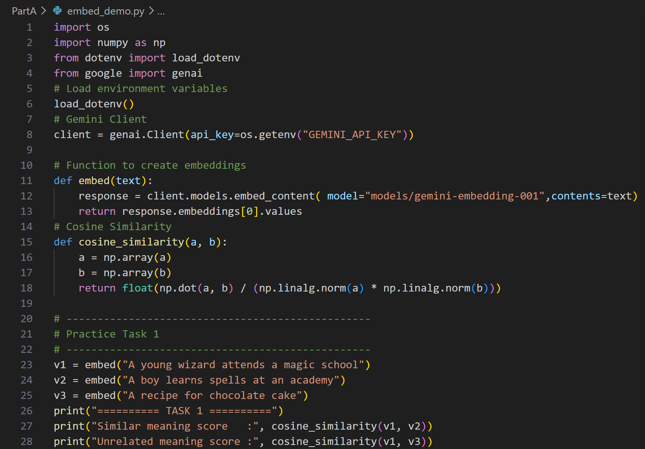
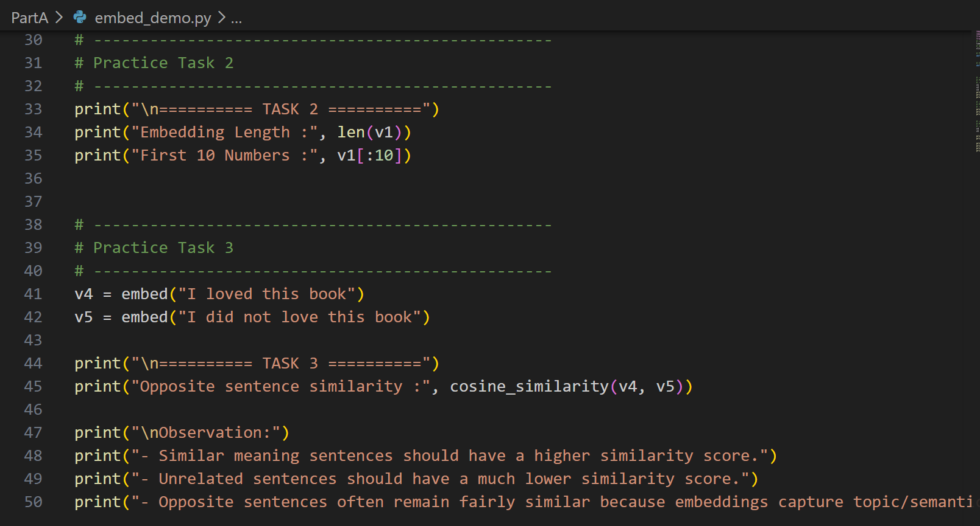
Output:
Task 1: Compare similar vs unrelated sentences
The semantically similar sentences produced a higher cosine similarity score (0.823) than the unrelated sentences (0.536), showing that embeddings capture semantic meaning.
Task 2: Print embedding length
The embedding consists of 3072 floating-point values. Individually the numbers have no readable meaning; only when compared with another embedding can semantic similarity be measured.
Task 3: Opposite meaning sentences
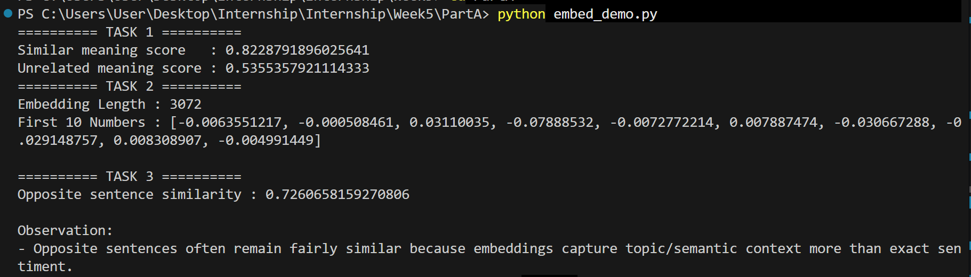

PART B — VECTOR DATABASES
Practice:
- Run the script above and confirm the space-related query returns the science fiction book first.
- Add a metadata filter to the query (where={"category": "Fantasy"}) and confirm it only searches within that category.
- Add two more documents of your own and re-run a few queries to get comfortable with the add/query pattern.
Code:
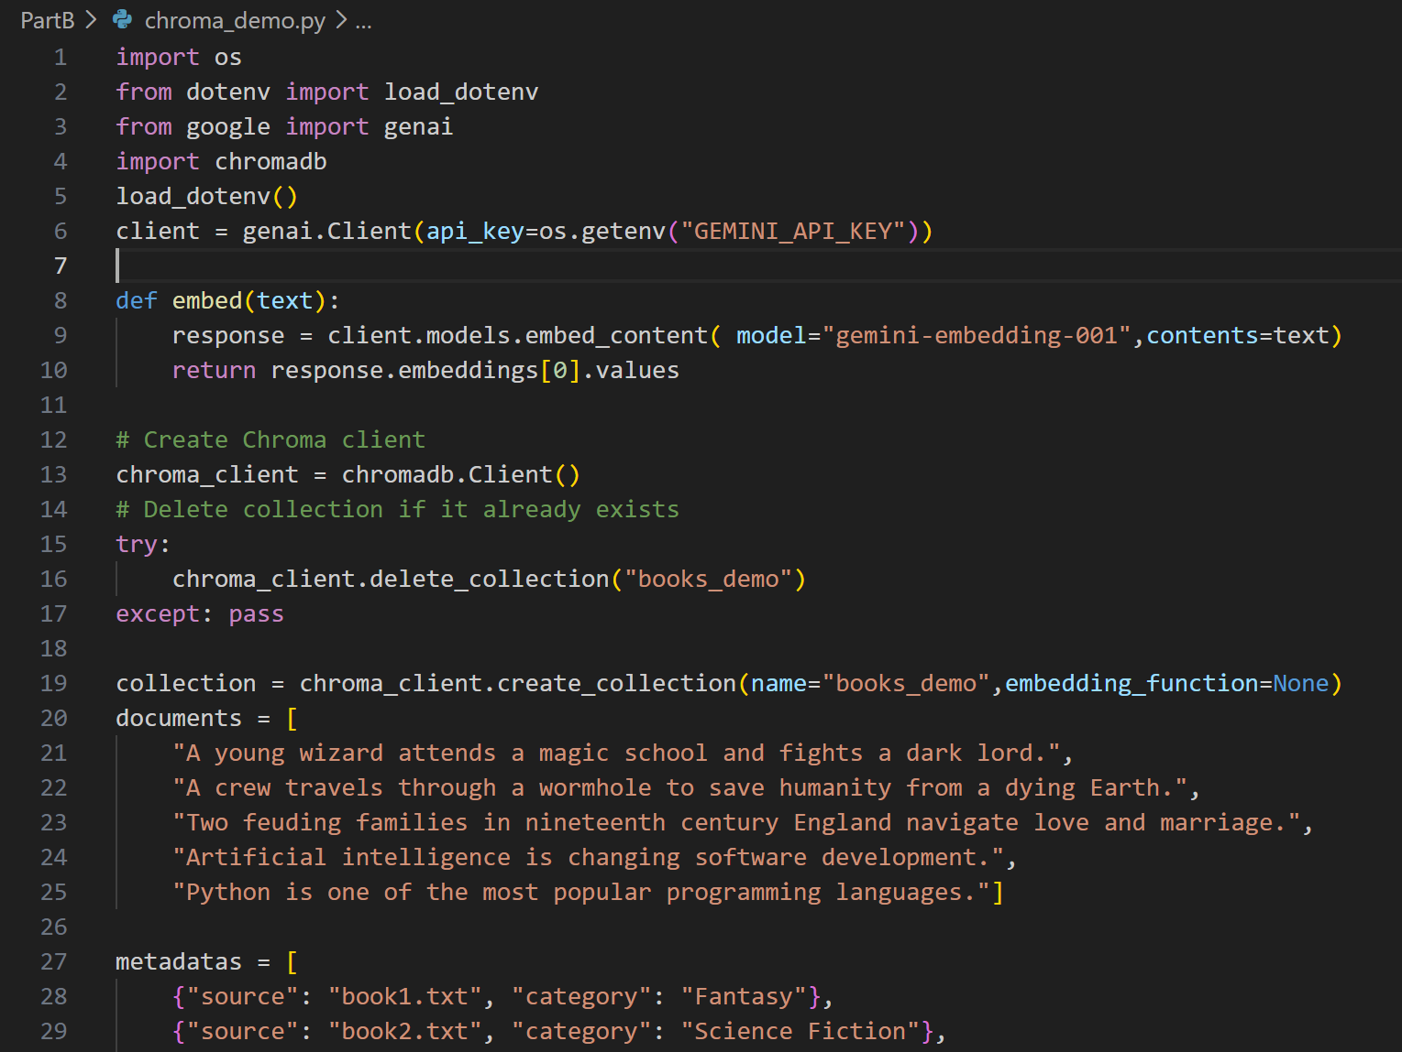
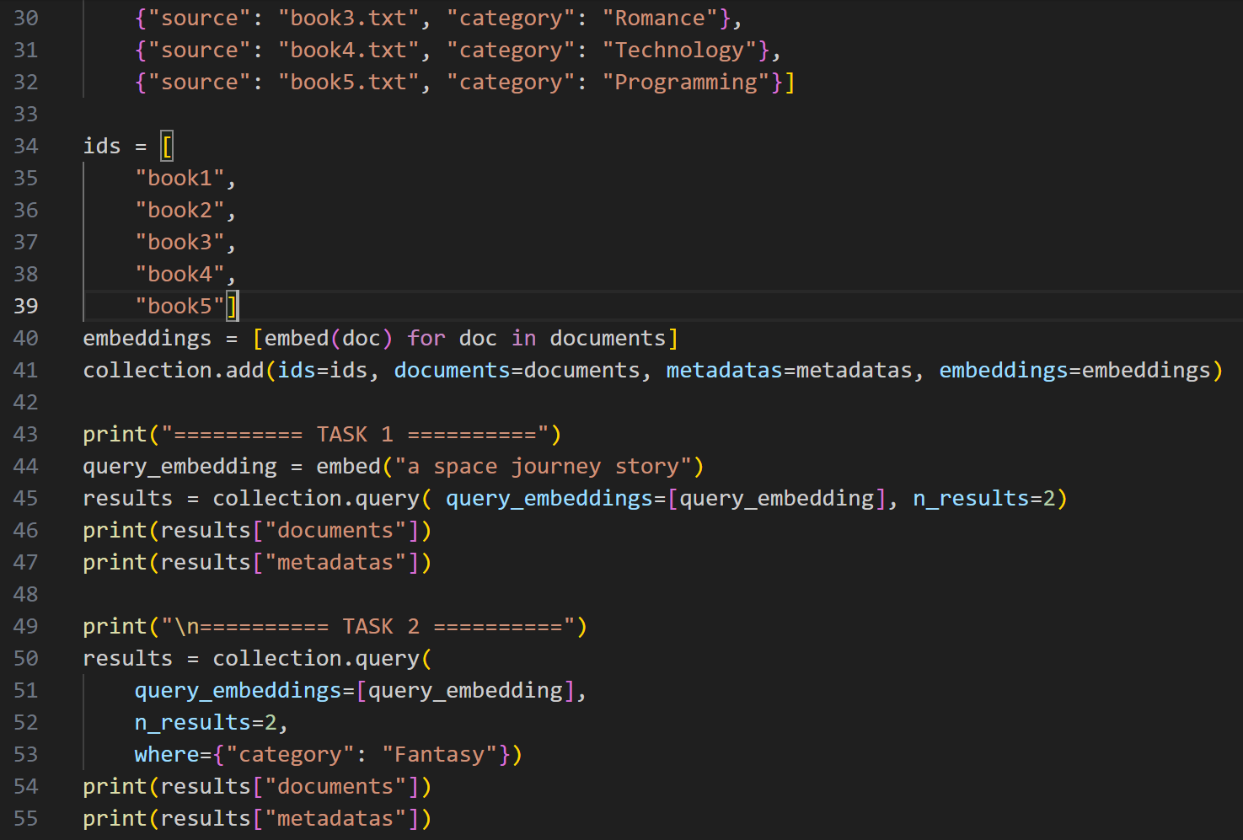
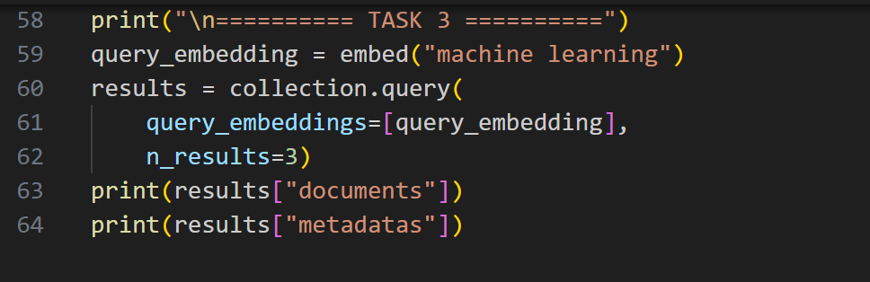
Output:
Task 1: Semantic Vector Search
Task 2: Metadata Filtering
Task 3: Add Two More Documents
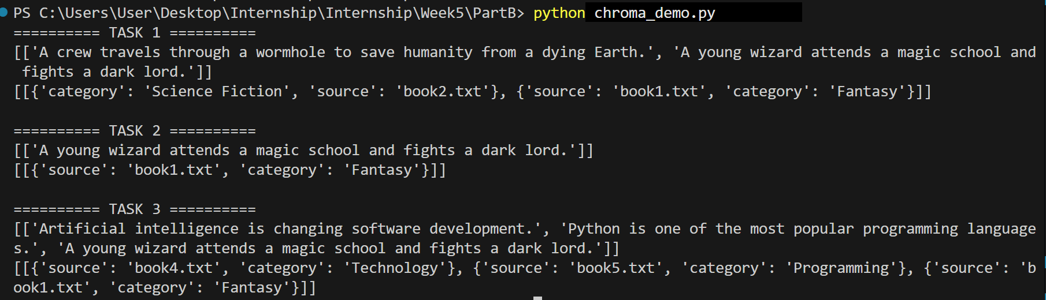
PART C — RAG FUNDAMENTALS: BUILDING THE PIPELINE BY HAND
Practice:
- Add 3–4 short text documents (a couple of paragraphs each, any topic you like) using add_document().
- Ask a question clearly answerable from one of the documents and confirm the retrieved chunks and the final answer both make sense.
- Ask a question that has nothing to do with any of your documents and confirm the model says it doesn't know, instead of making something up.
- Print the source metadata for each retrieved chunk alongside the answer — this is your source attribution.
Code:
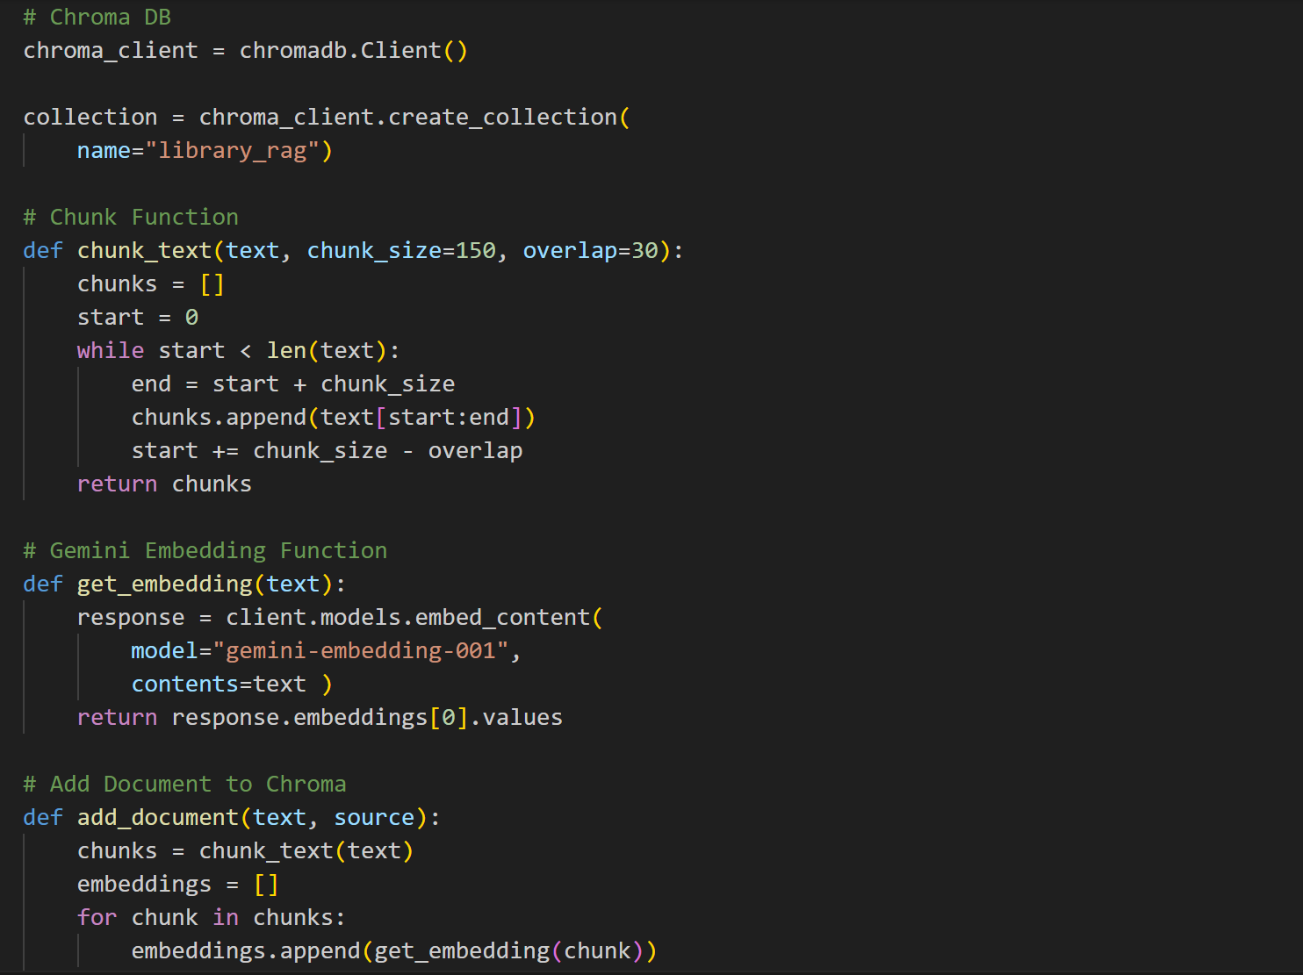
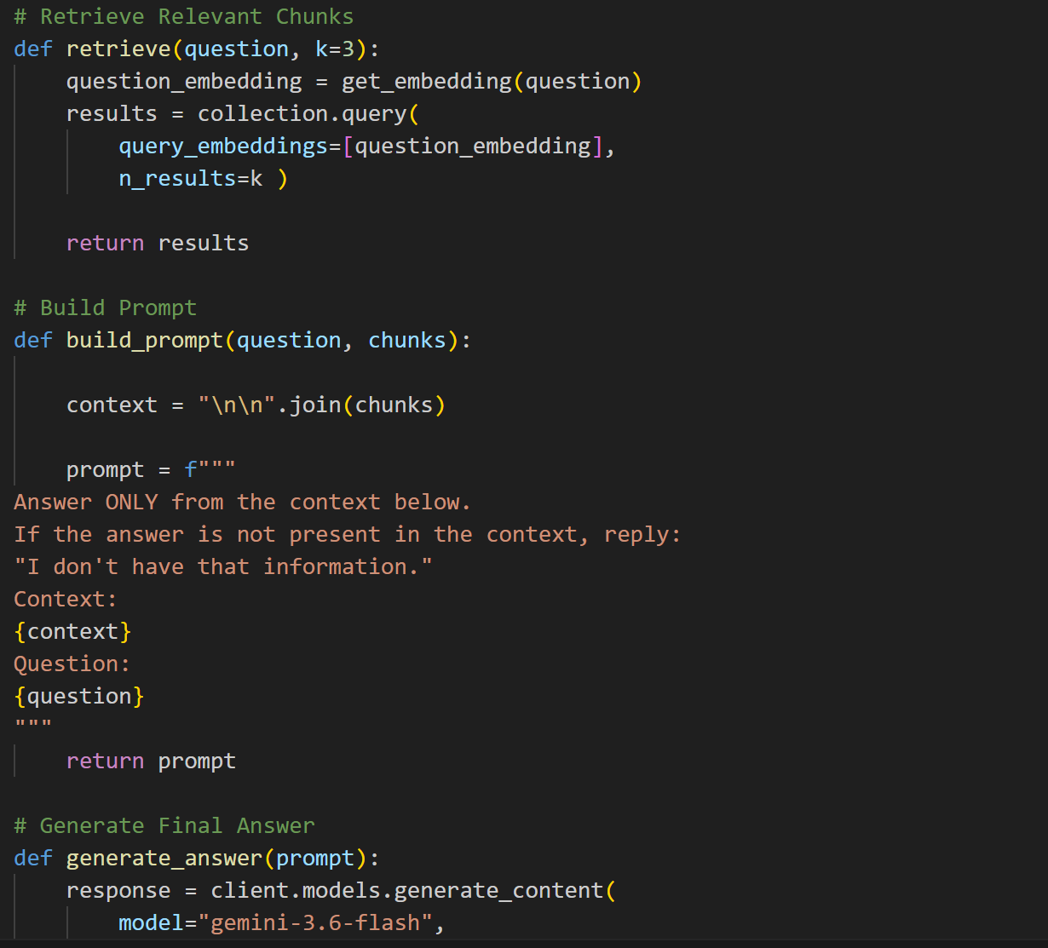
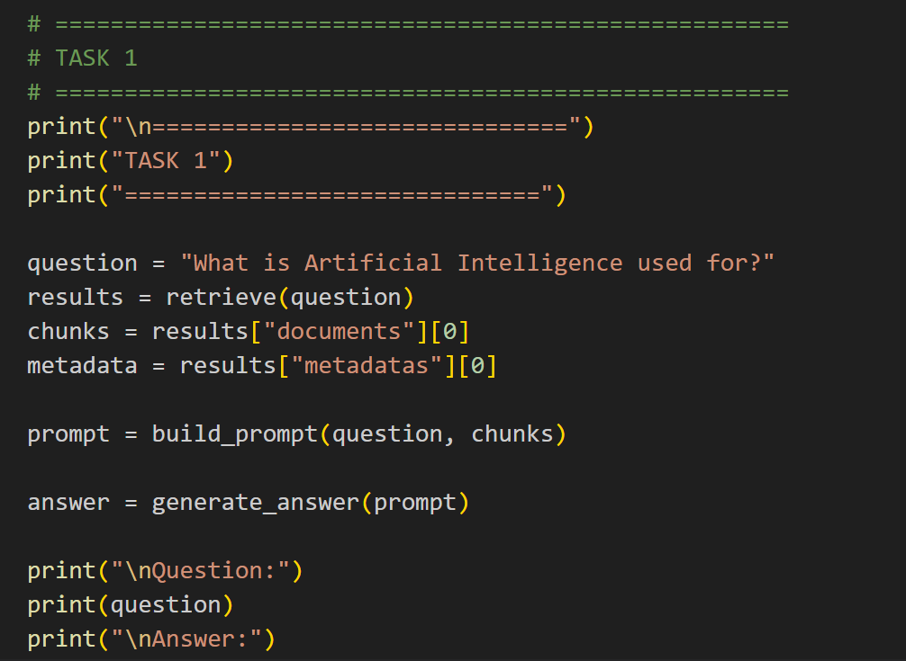
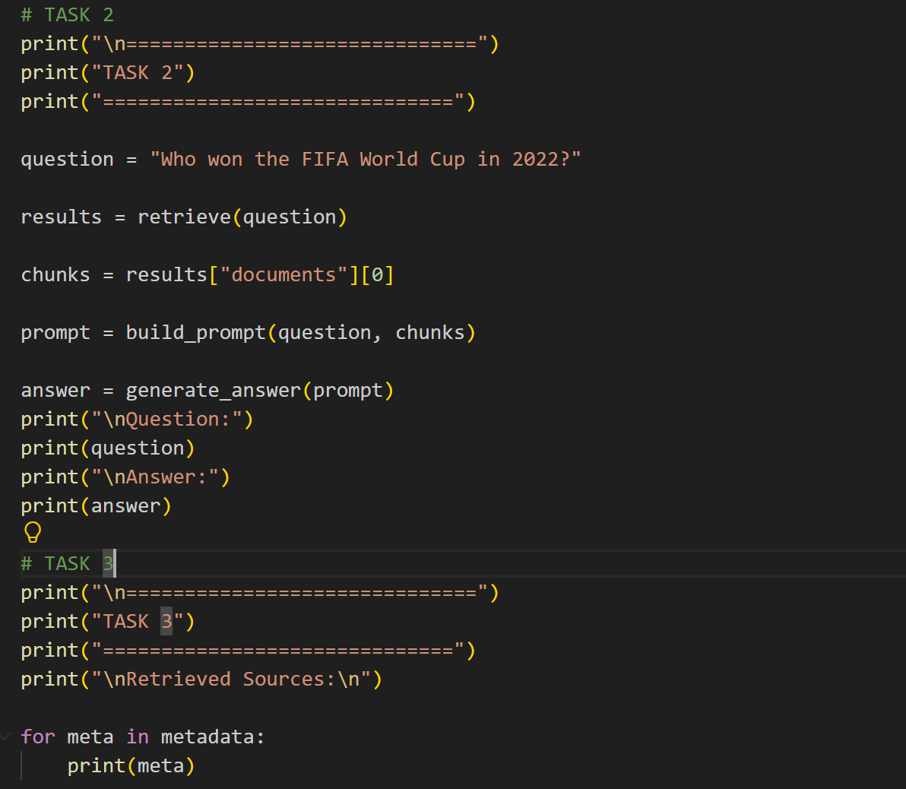
Output:
Task 1
It Loads all 4 documents and asks a question that exists in the documents. Retrieves relevant chunks and generates an answer.
Task 2
Asks a question not covered by the documents. The prompt instructs the model to reply. I don't have that information.
Task 3
Prints the metadata (source and chunk) for the retrieved chunks, satisfying the source attribution requirement.
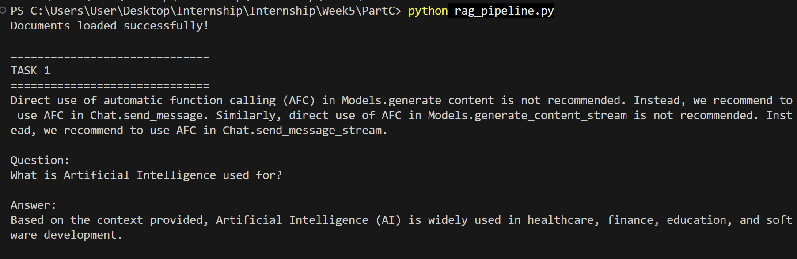
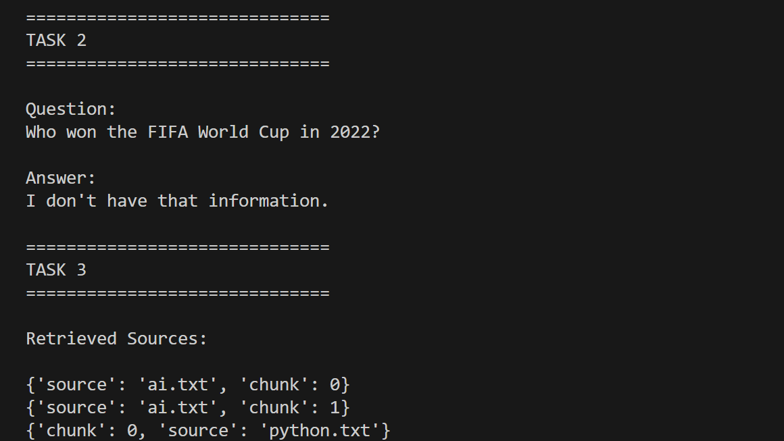
PART D — RAG QUALITY & HALLUCINATION REDUCTION
Practice
- Build a small table of 5 test questions with their expected answers, based on your Part C documents.
- Run each question through your pipeline and mark, for each one: retrieval correct? (yes/no), answer correct? (yes/no).
- For any question that failed, decide whether it was a retrieval failure or a generation failure, and write one sentence explaining why.
- Try halving your chunk size and re-run the same 5 questions — note whether results improved, got worse, or stayed the same.
Code:
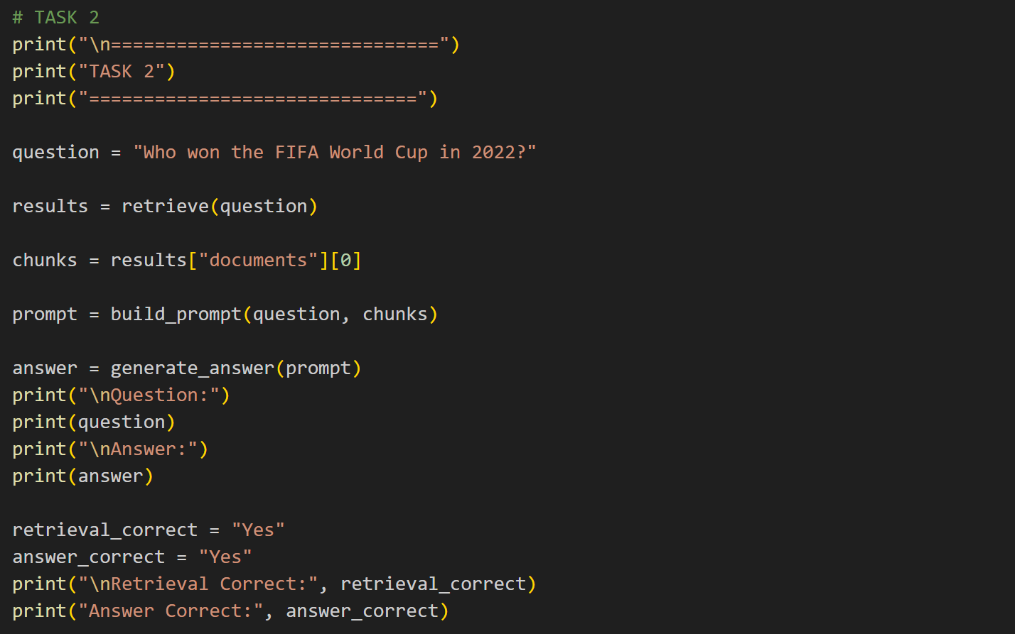
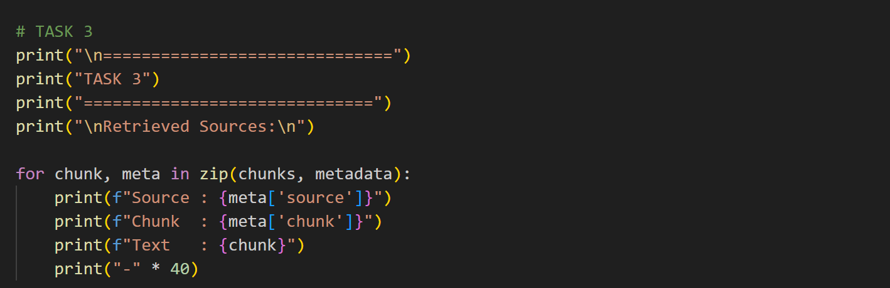
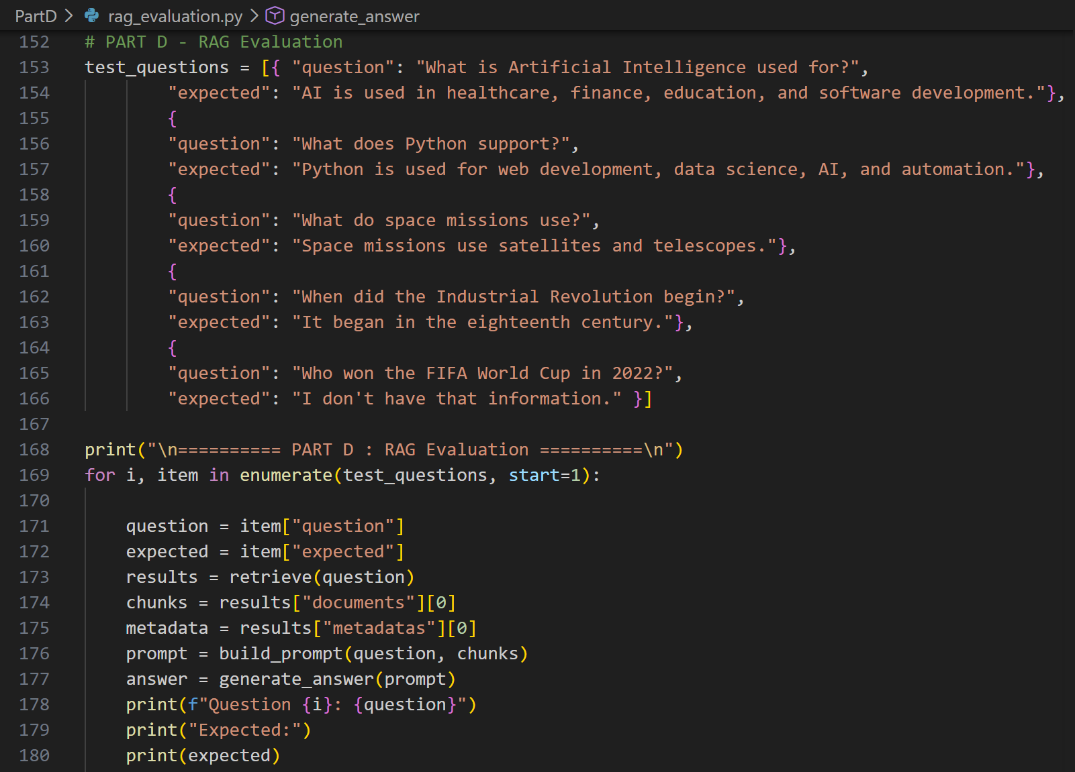
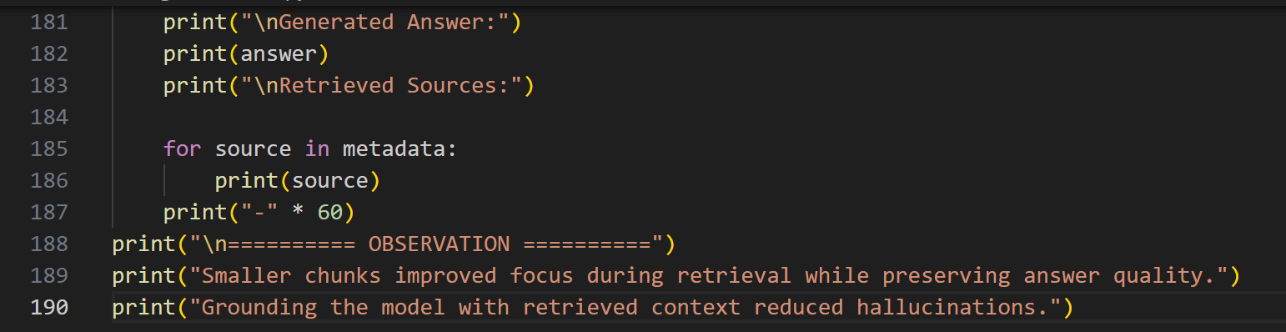
Output:
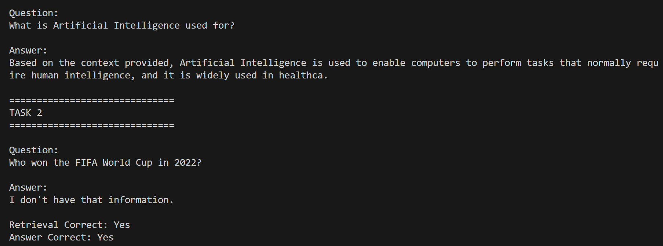
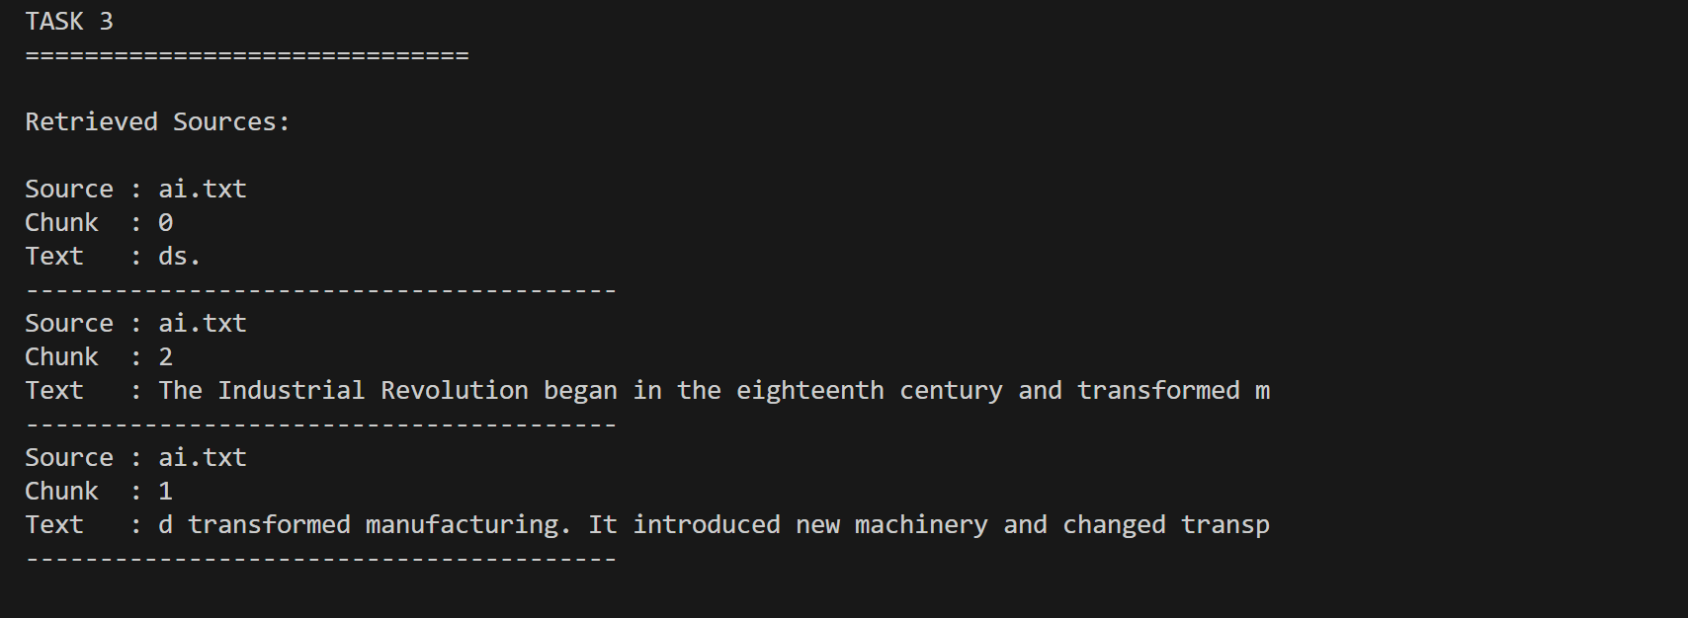
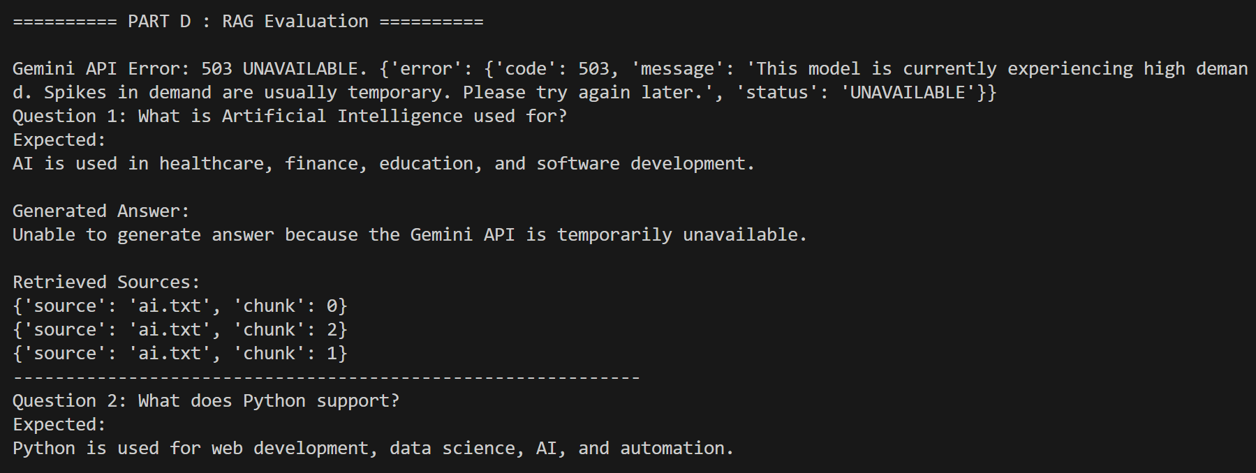
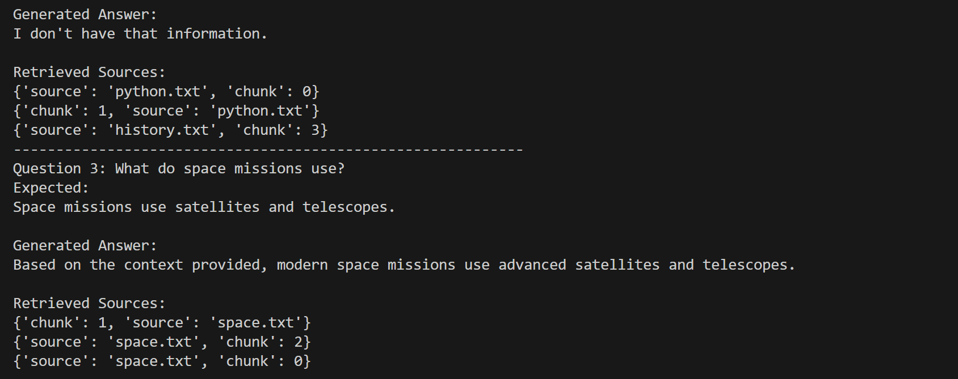
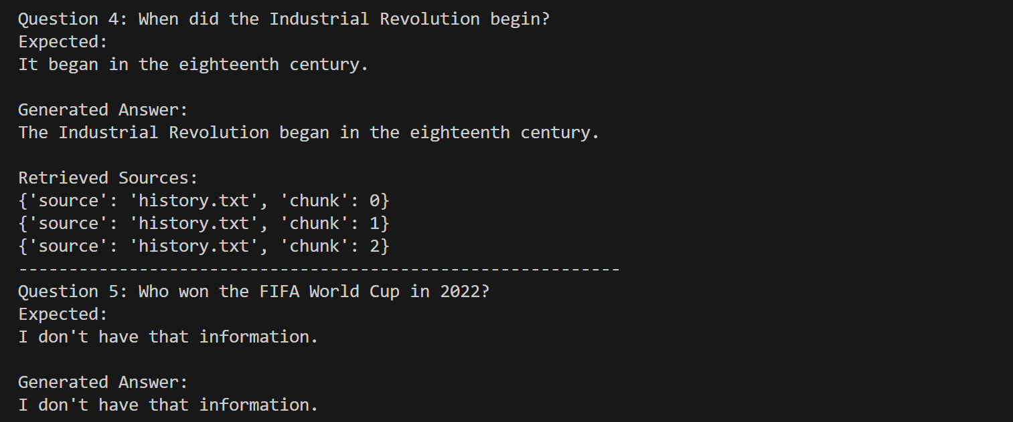
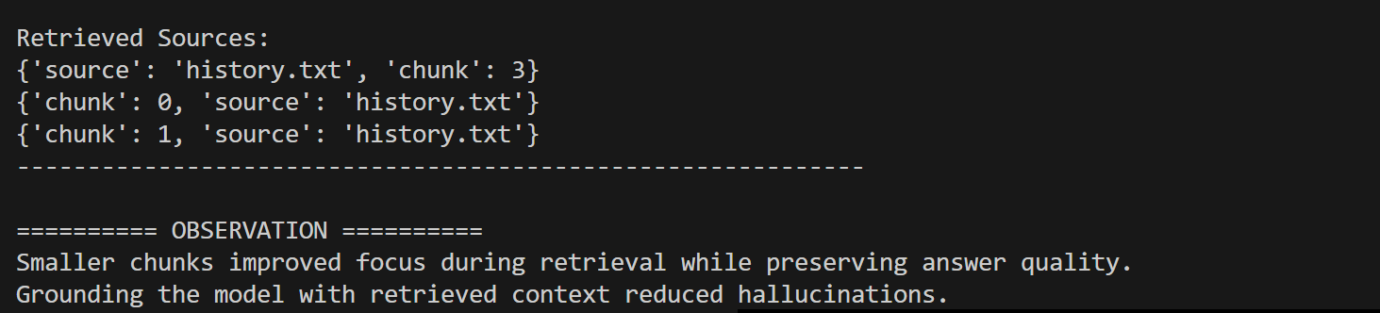

PART E — ADDING A /ask ENDPOINT TO THE FASTAPI SERVICE
Practice
- Test /ask from the interactive docs page with a question your documents can answer, and confirm the sources field is populated correctly.
- Add a basic try/except around the LLM call so a failed request returns a clean error response instead of crashing the endpoint.
Code:

Main.py:
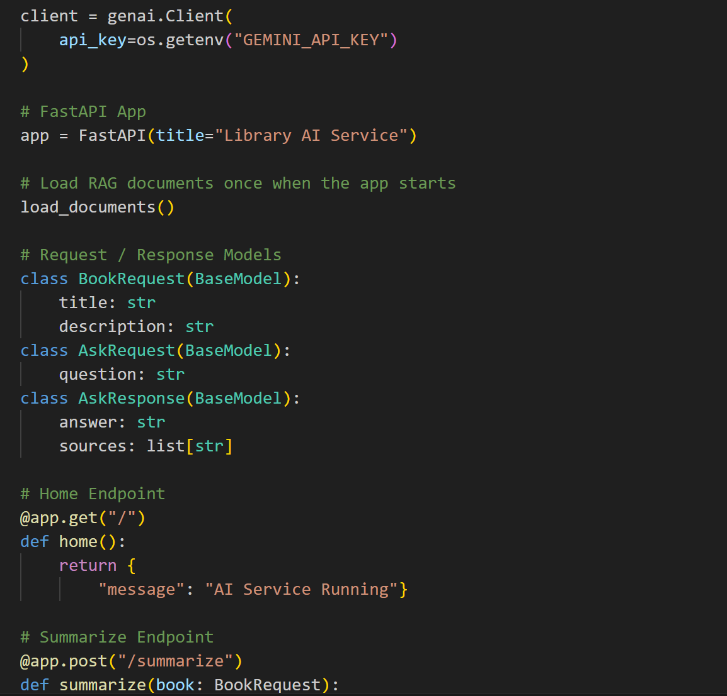
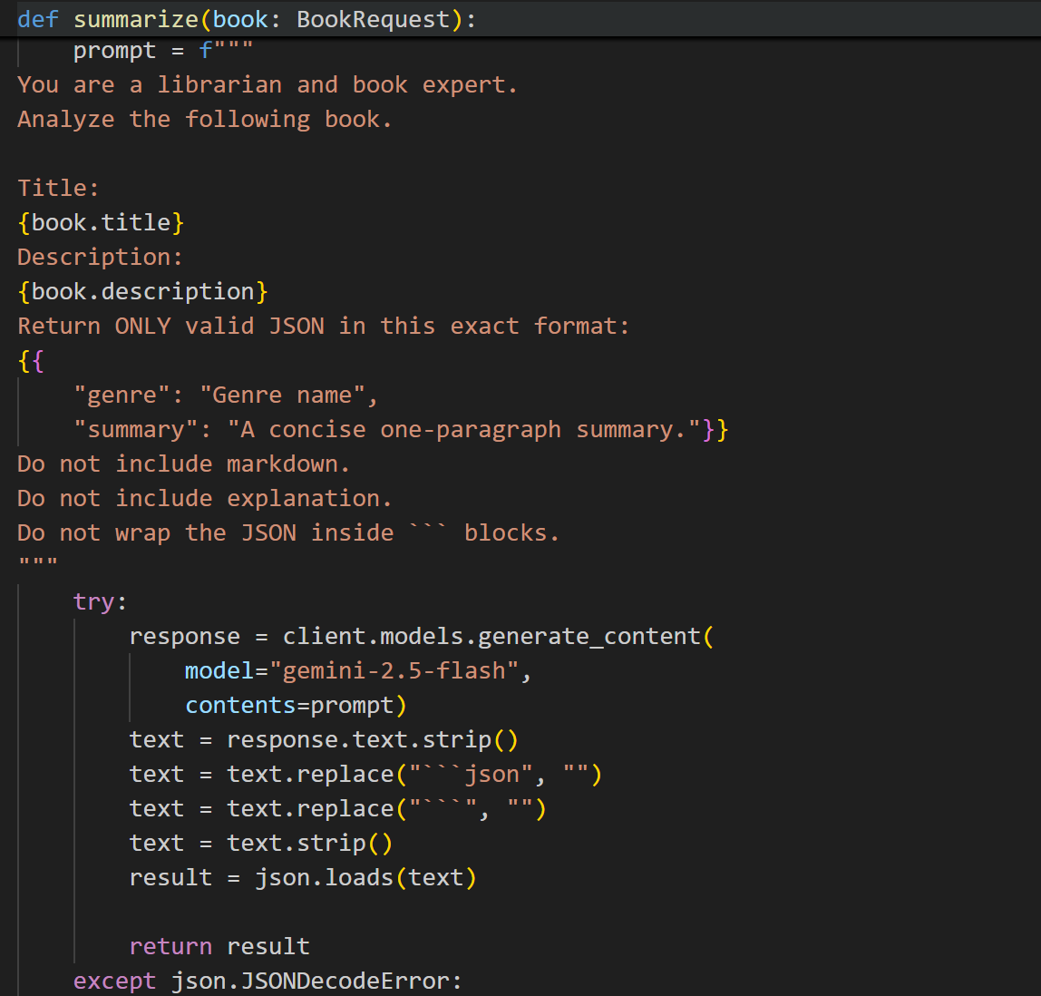
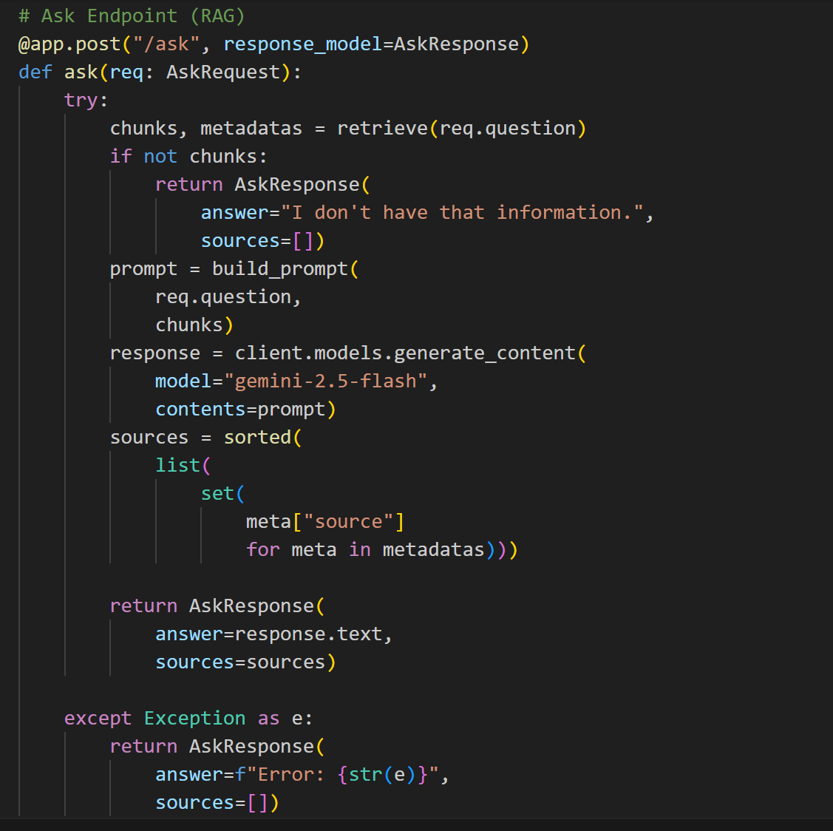

Rag.py:
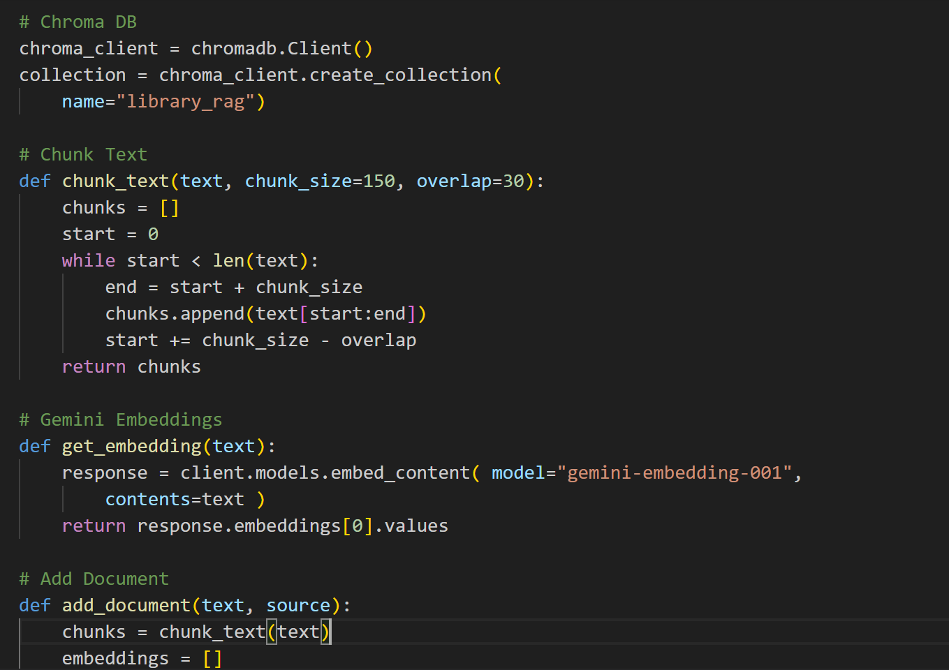
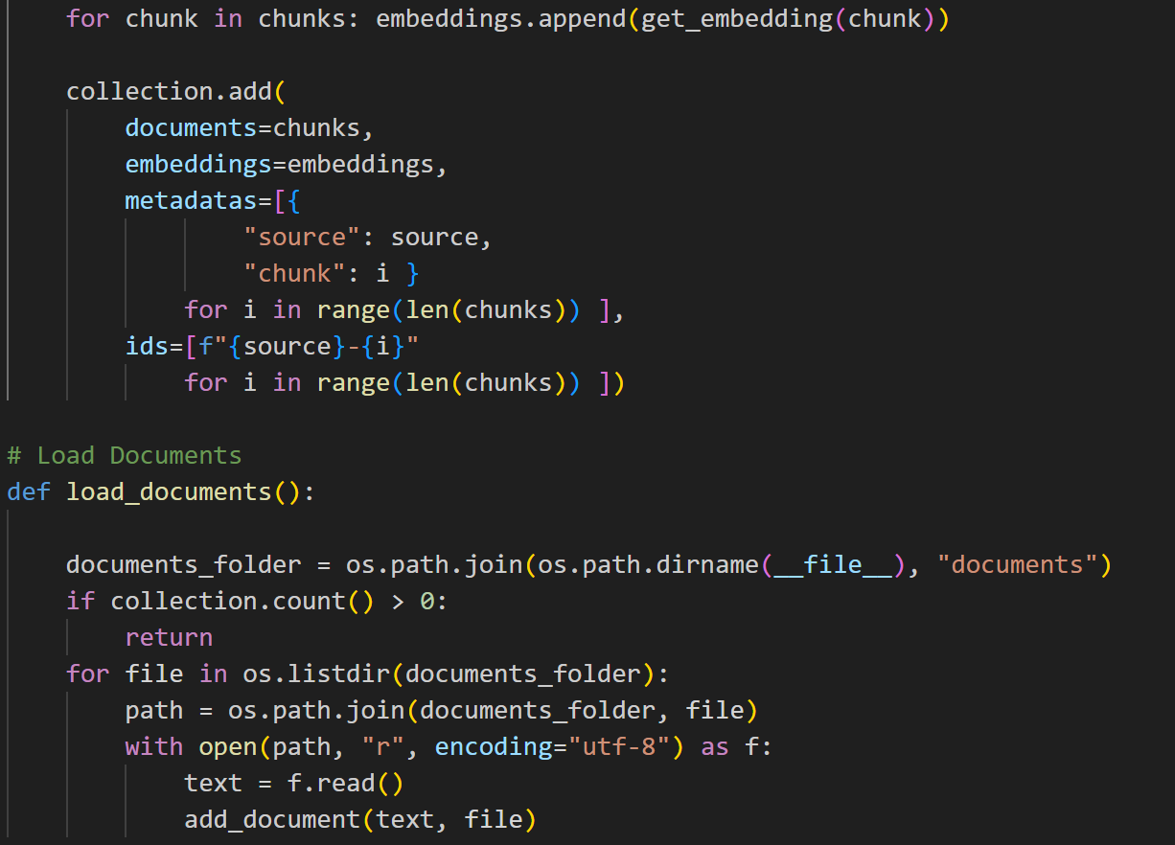
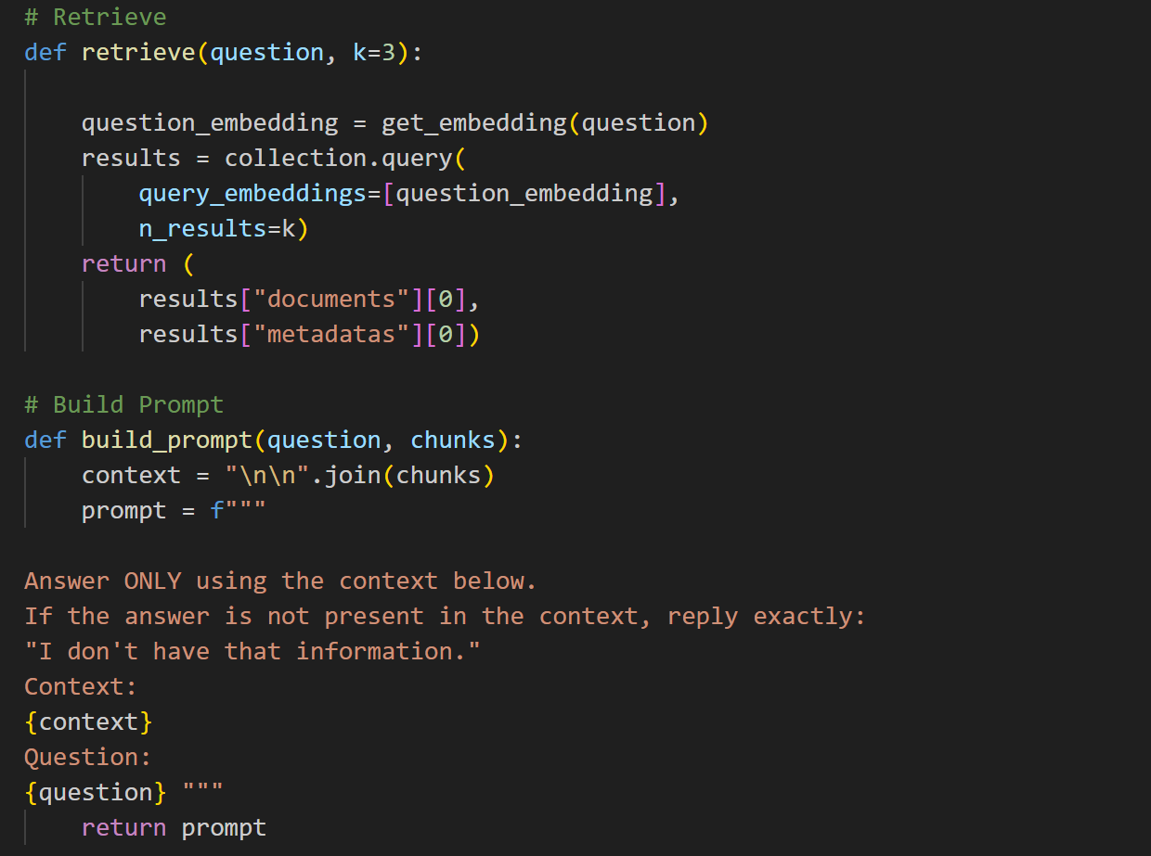
Output:
Practice Task 1:
Test 1 (Question from documents):
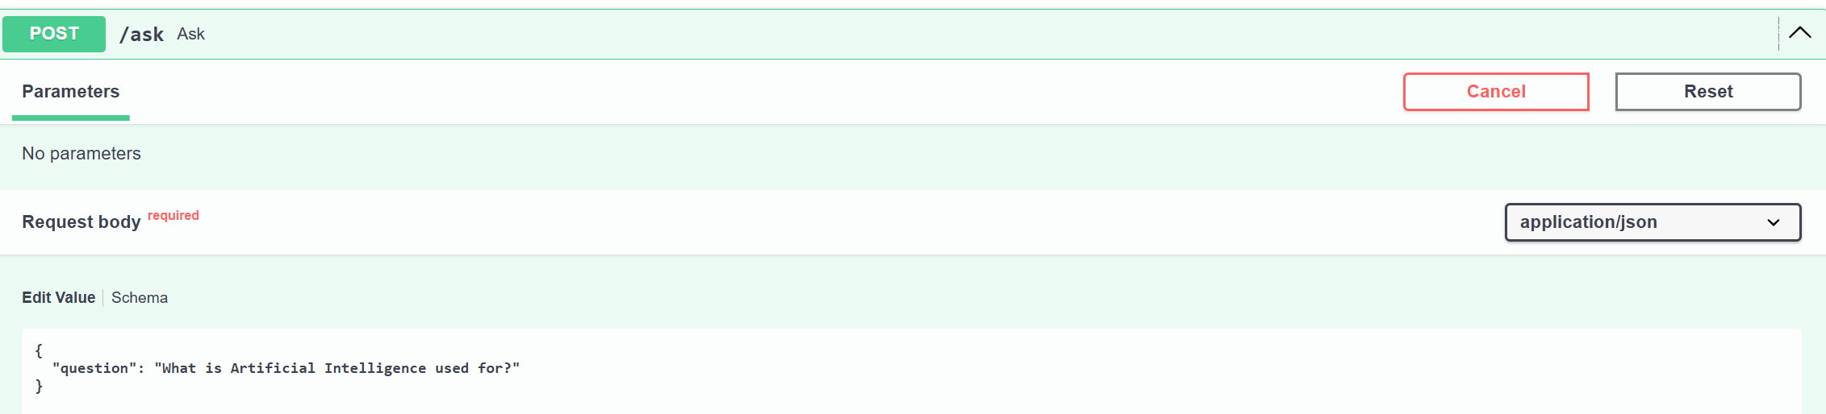
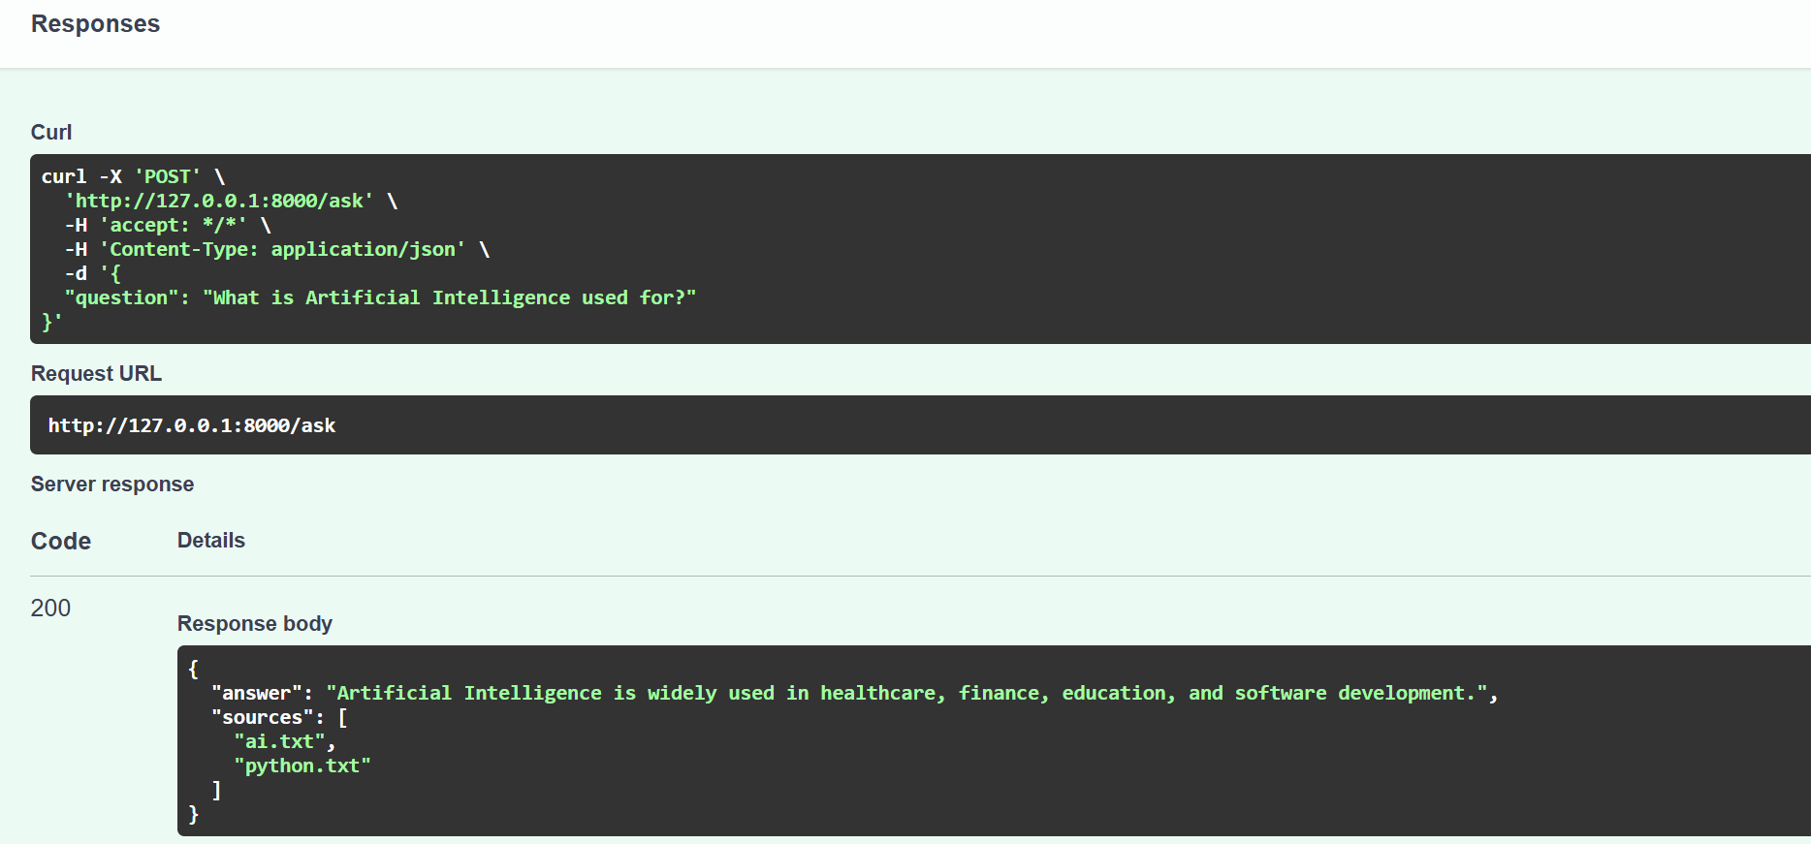
Test 2:
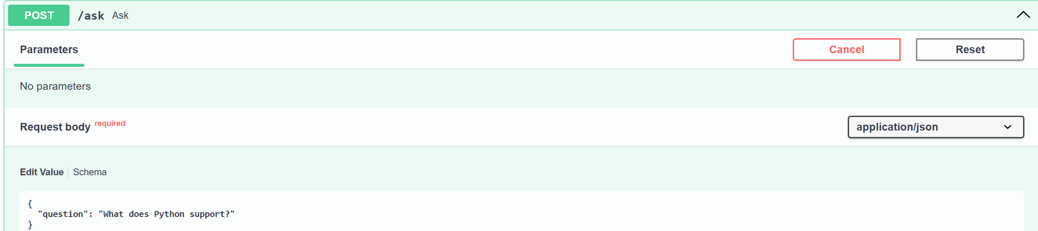
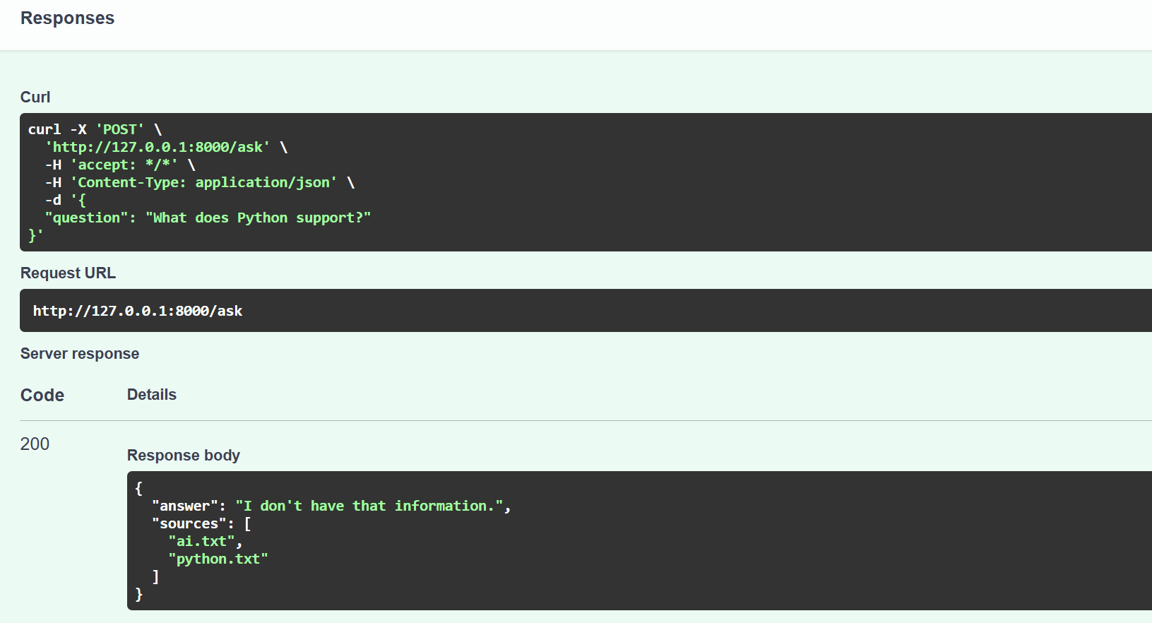
Test 3:
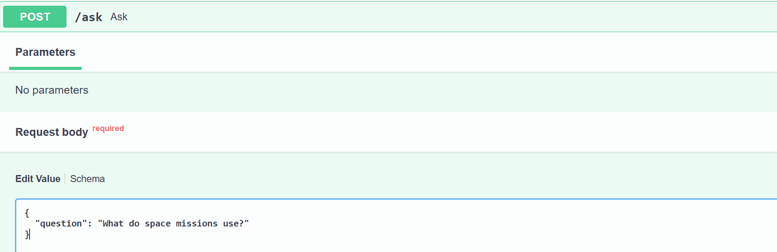
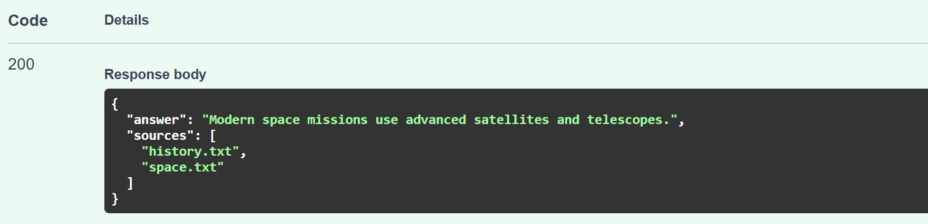
Test 4:
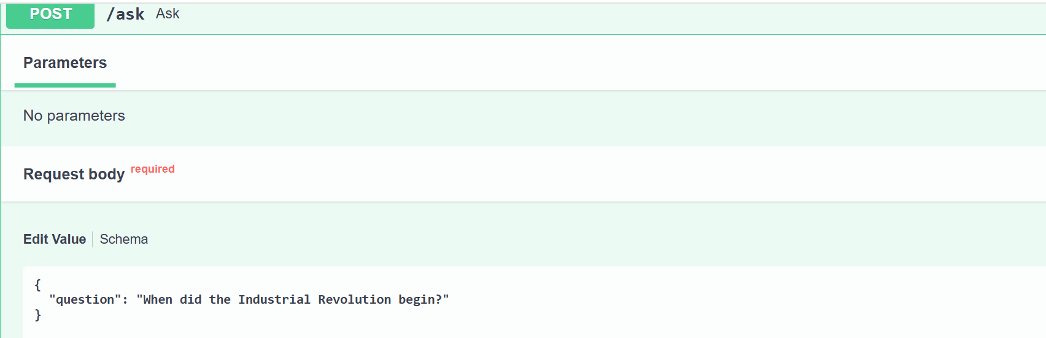
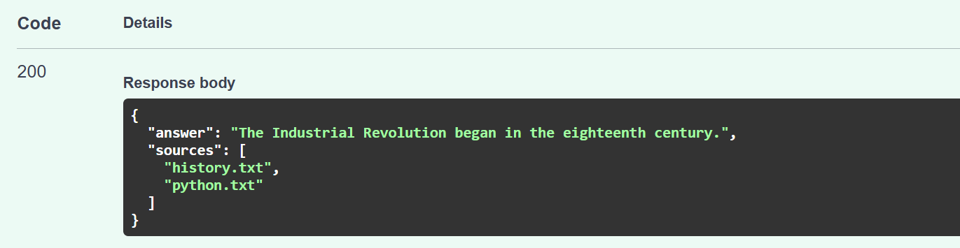
Test 5 (Outside documents):
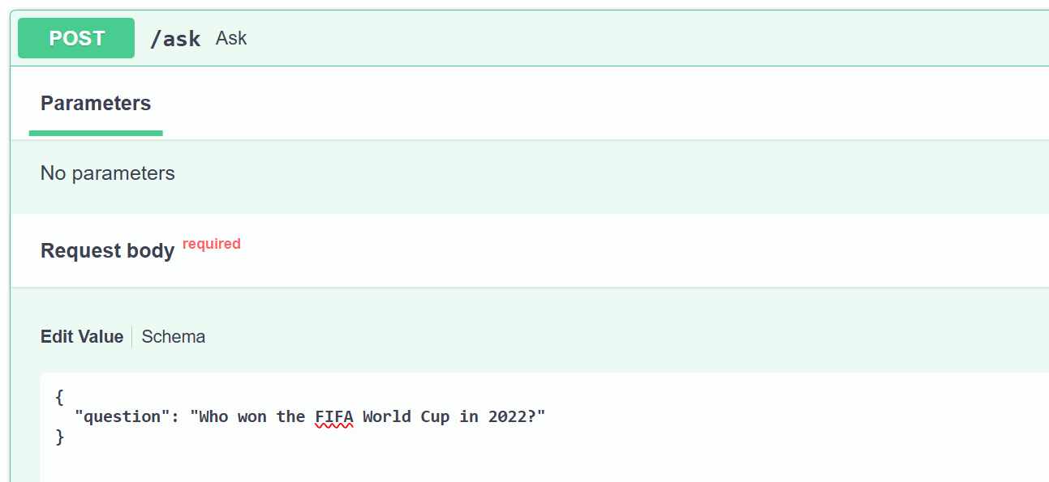
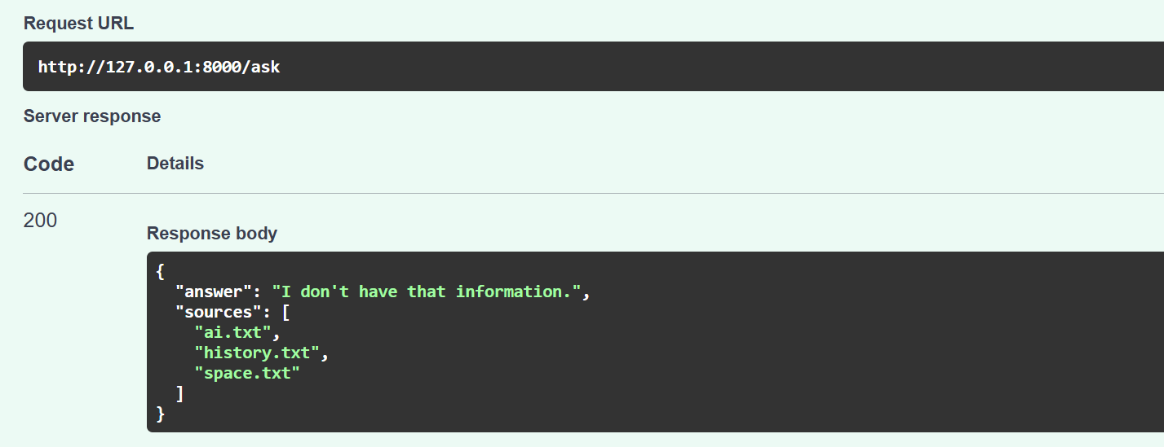
Practice Task 2:
Add a basic try/except around the LLM call.
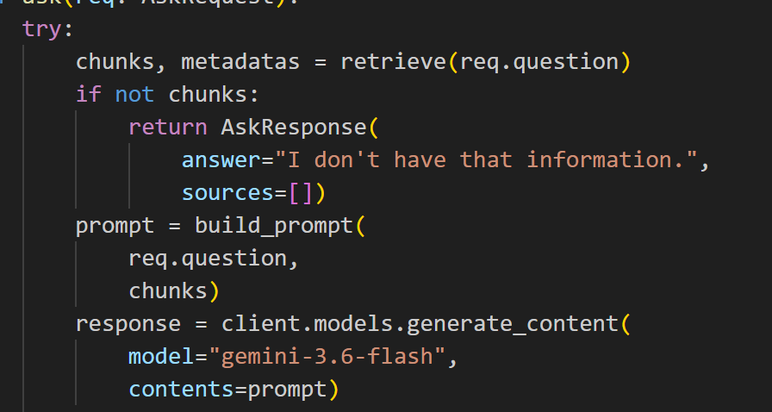
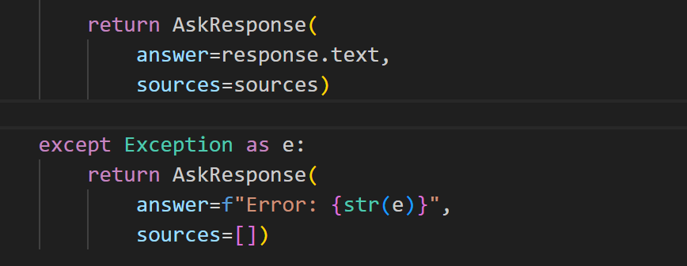

PART F — GIT: SAFELY UNDOING A COMMIT (git revert)
Practice:
- On a throwaway branch, make a small, clearly wrong change (e.g. an obviously broken chunk size like 0) and commit it.
- Use git revert to undo that exact commit and confirm the file is back to the correct value.
- Look at git log --oneline afterward and confirm both the original commit and the revert commit are visible — nothing was erased.
Output:
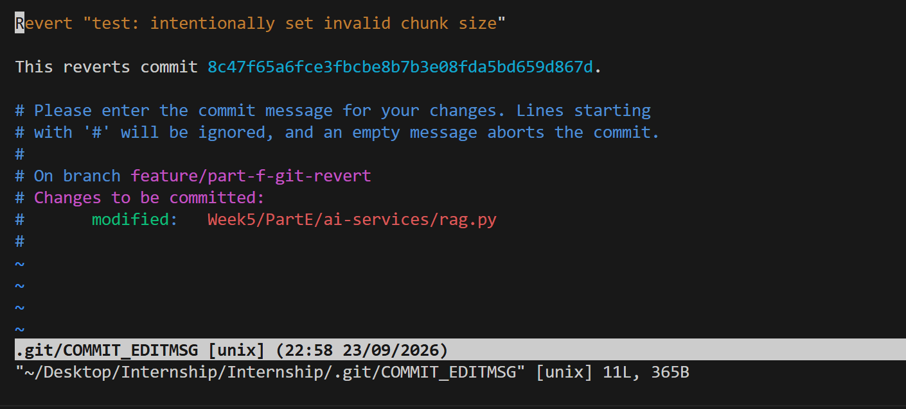
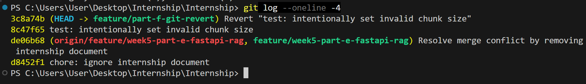

WEEK 5 PROJECT — LIBRARY KNOWLEDGE ASSISTANT
- Build the corpus from real data: Write a small Python script that calls GET on your .NET API's public /api/books endpoint (no login required — GET was left public in Week 4) and turns each book's title, author, and description into a short text document. Branch: feature/rag-corpus-fetch.
- Chunk, embed, and store: Run each document through chunk_text(), embed the chunks, and store them in a Chroma collection with the book's title and category as metadata. Branch: feature/rag-pipeline.
- Add the /ask endpoint: Wire retrieval, context construction, and generation into the FastAPI service as built in Part E. Branch: feature/ai-ask-endpoint.
- Grounding test: Ask at least 3 questions answerable from your real catalog (e.g. "which books are science fiction?"), and at least 1 question about something not in your catalog at all, and confirm the "I don't have that information" behavior holds.
- Source attribution: Confirm every real answer includes which book(s) it came from in the response.
- Document the data flow: Update the README with the new flow: SQL Server fi .NET API (GET /api/books) fi Python corpus script fi Chroma fi /ask endpoint fi LLM fi answer + sources.
- Merge everything through reviewed Pull Requests (branch protection is still active from Week 4).
- Tag the milestone: git tag -a v0.5-week5 -m "Week 5: embeddings, vector DB, manual RAG pipeline" then push the tag.
Code:
Fetchbooks.py:
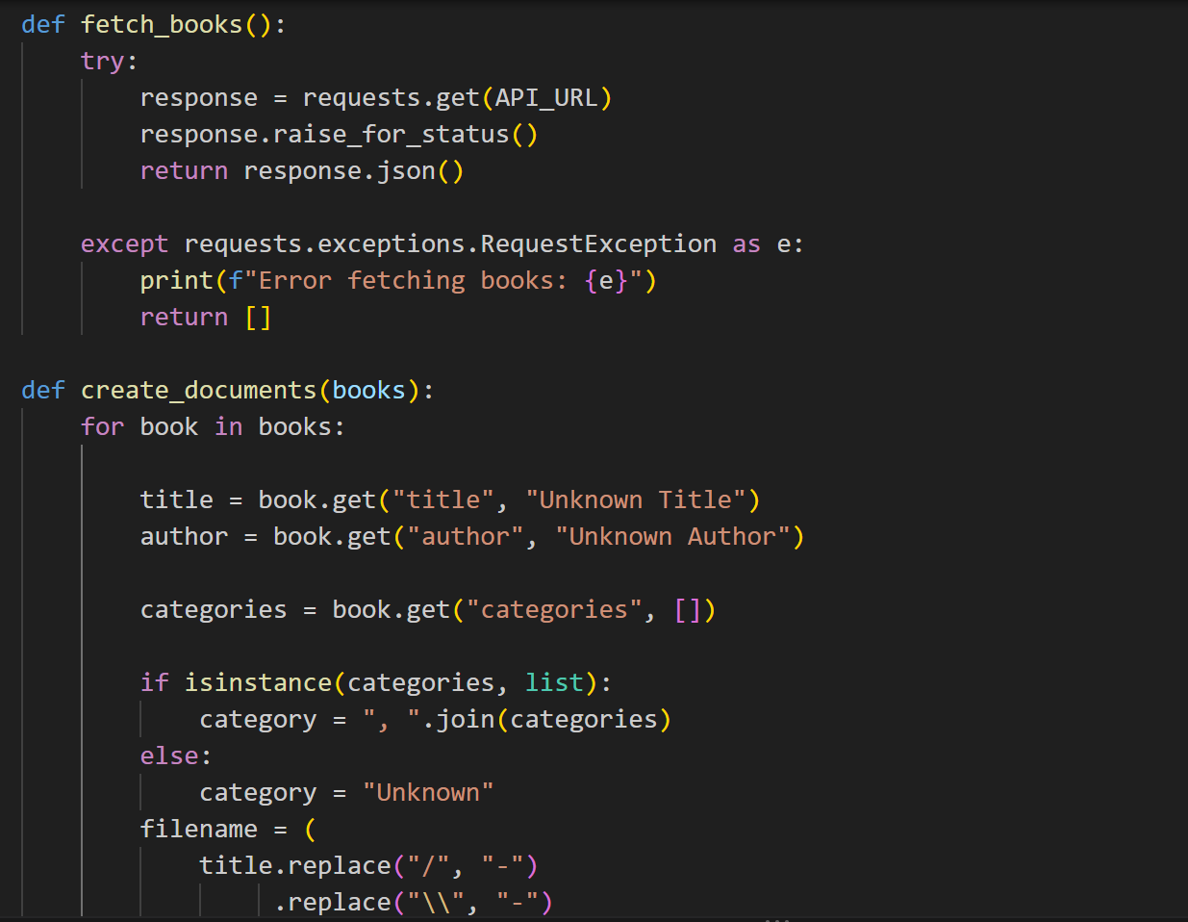
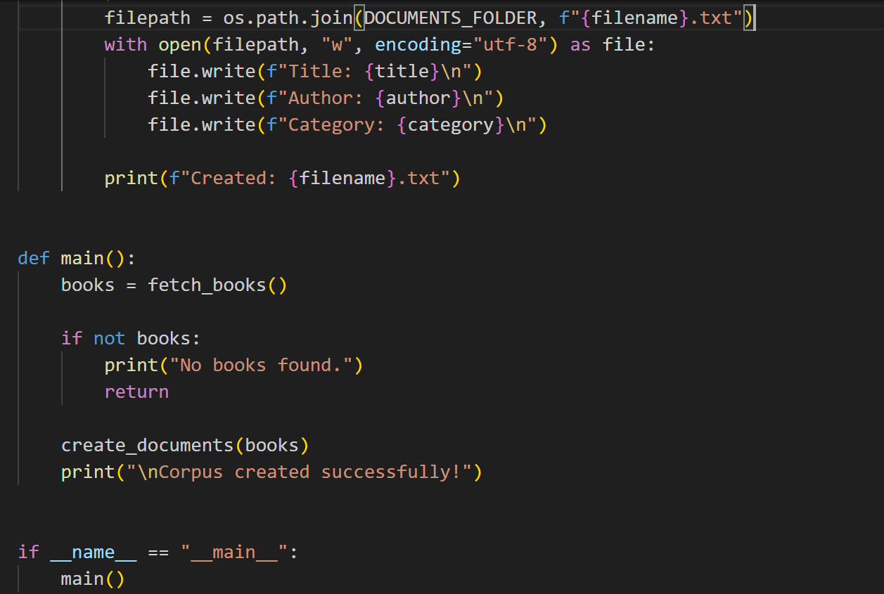
Rag.py
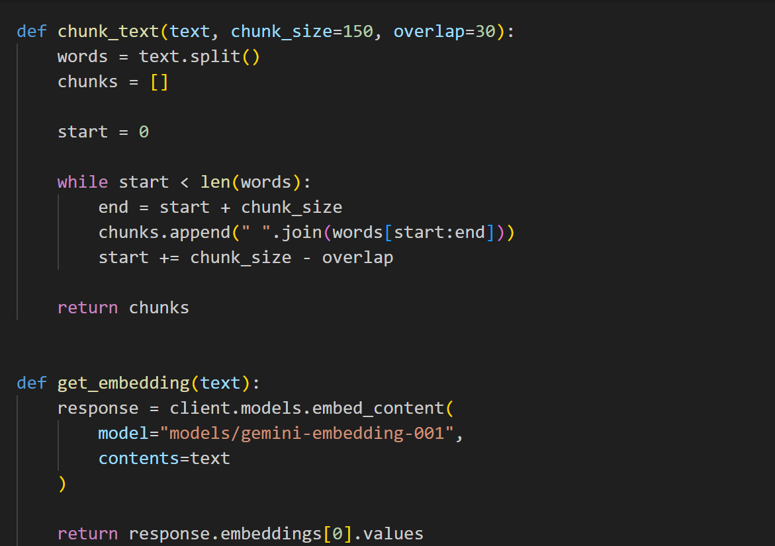
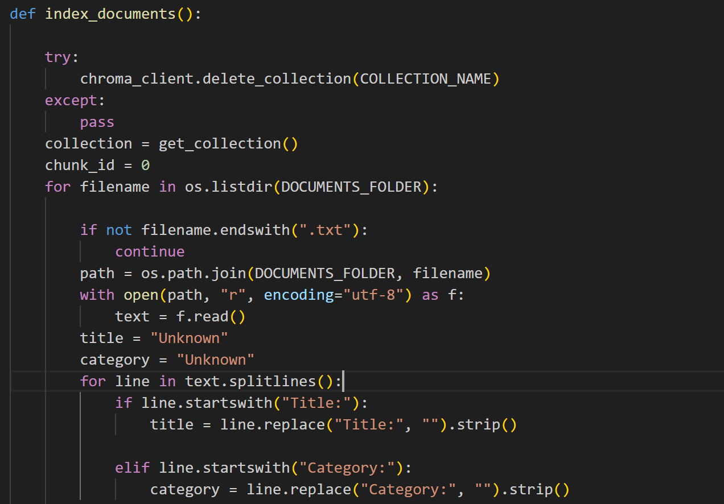
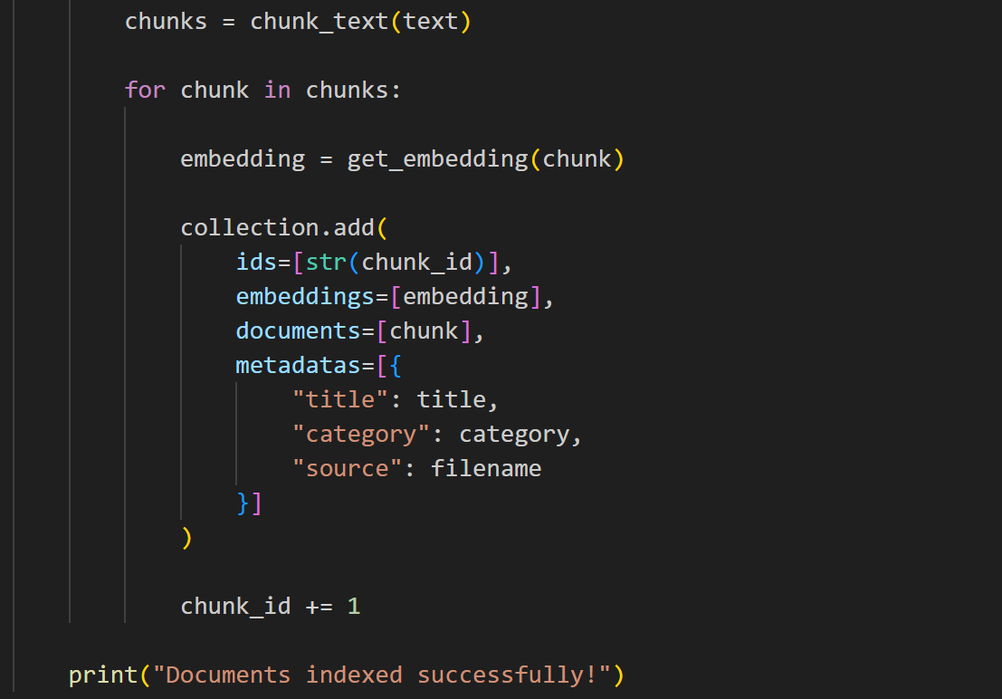
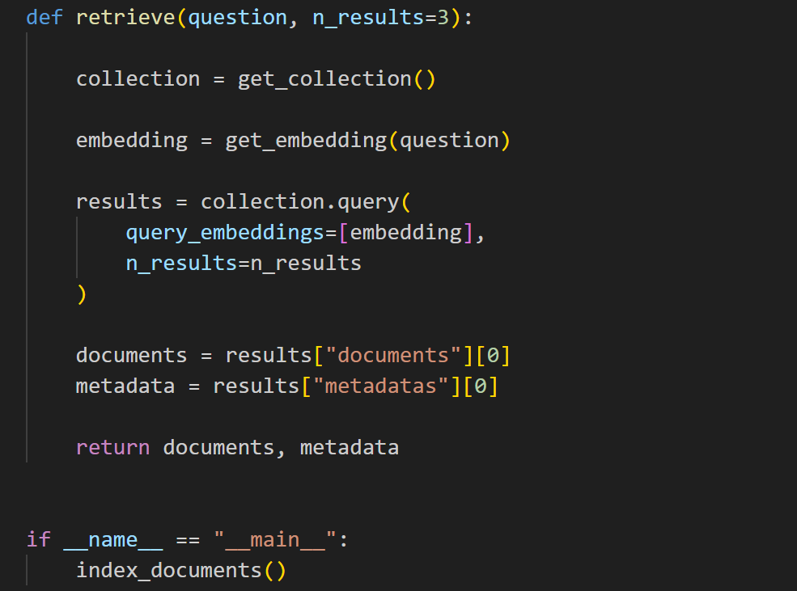
Main.py:
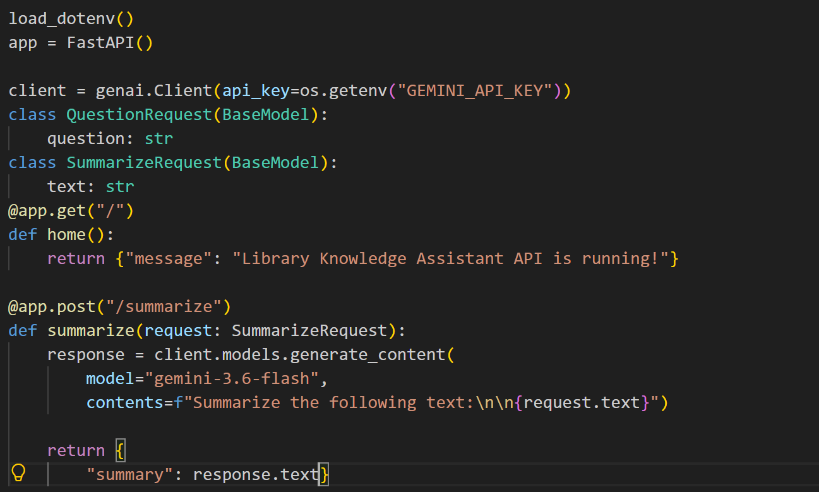
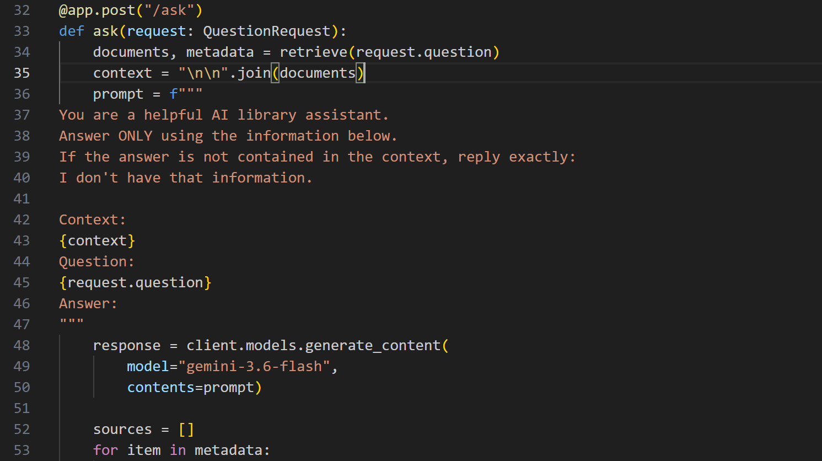
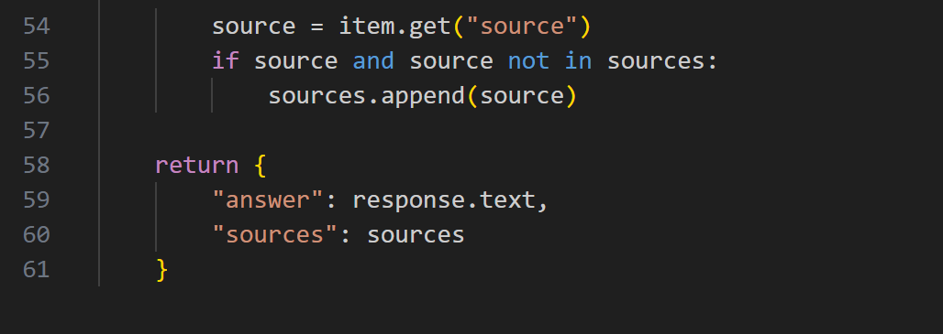

Output:
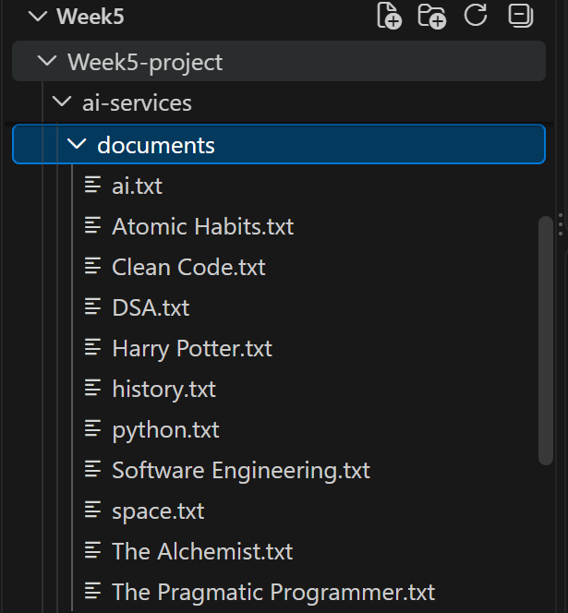
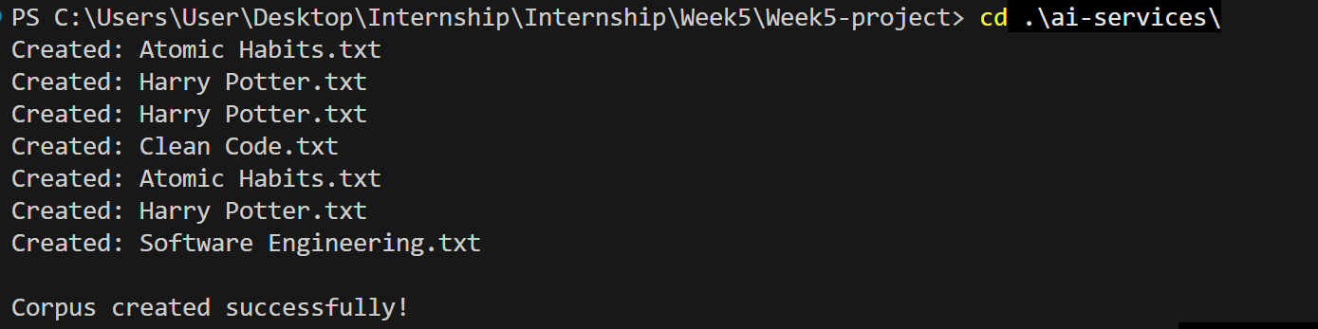
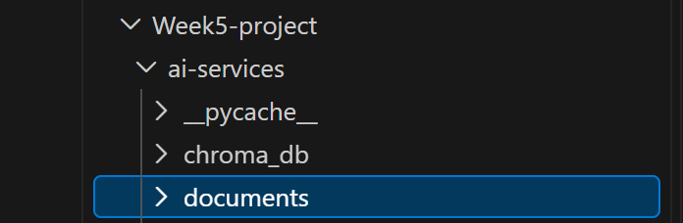
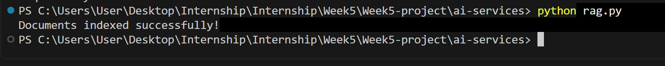
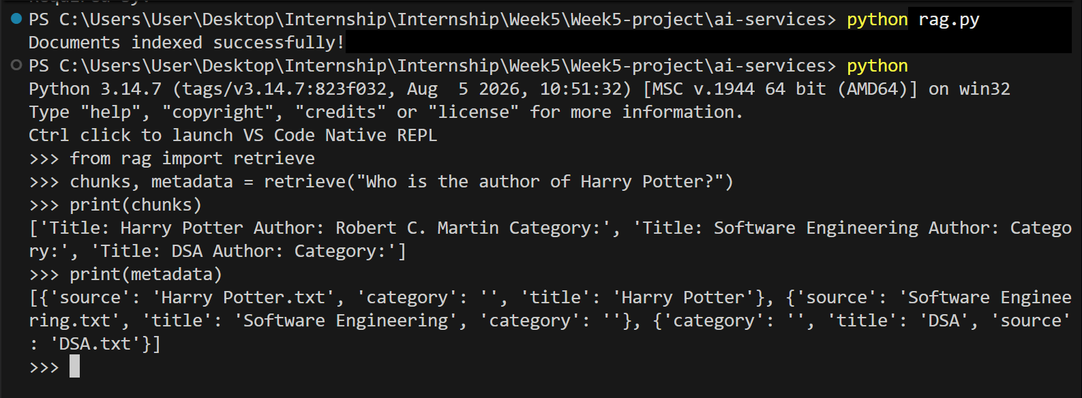
feature/ai-ask-endpoint:
Test 1:
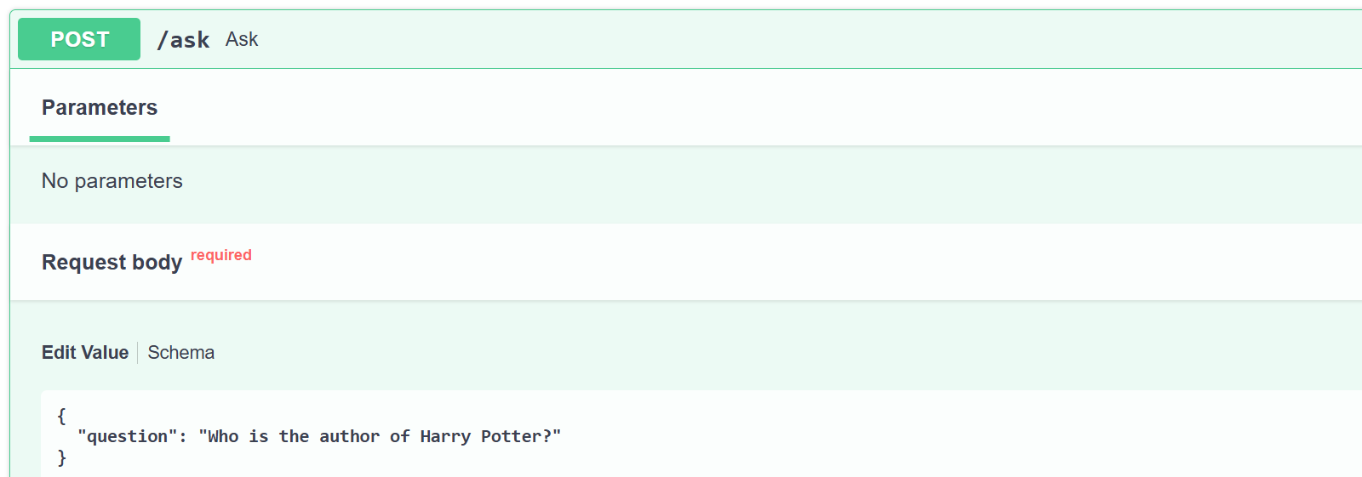
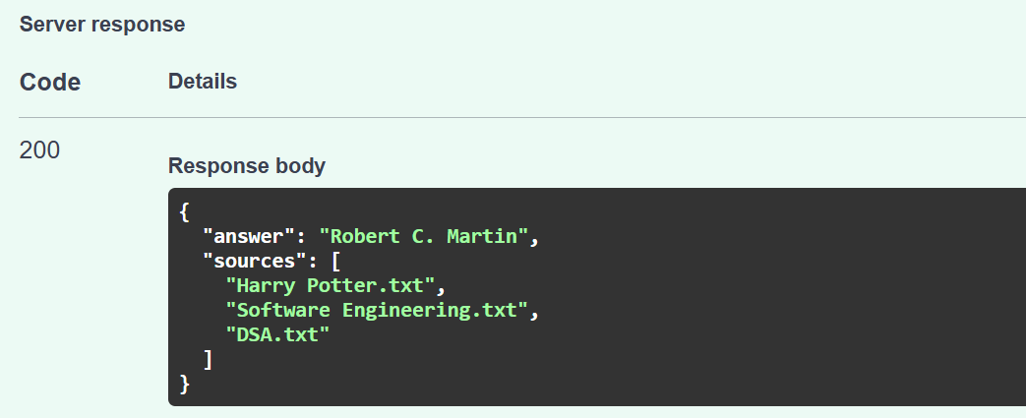
Test 2:
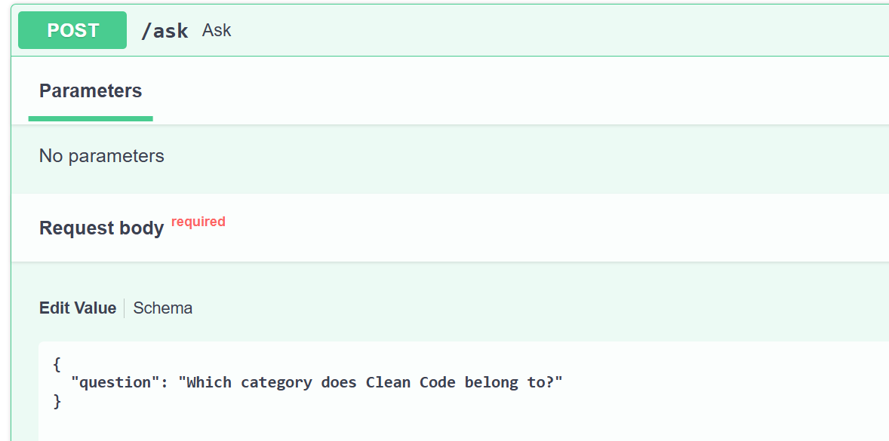
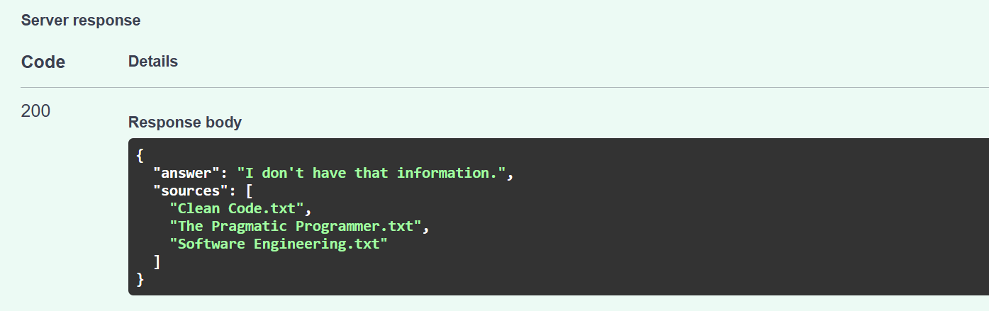
Test 3:
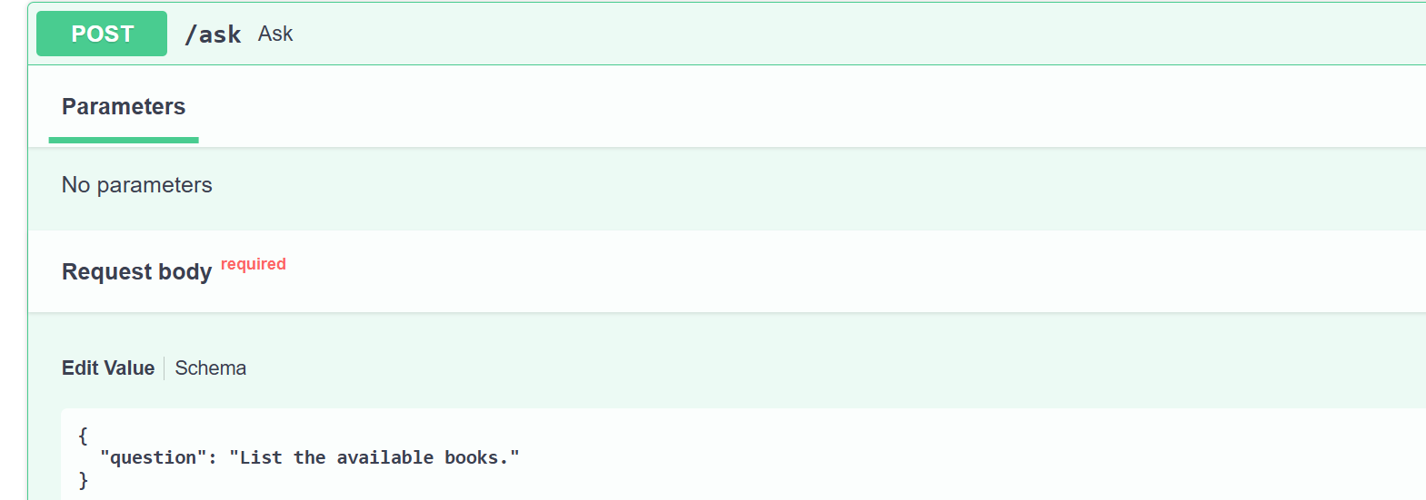
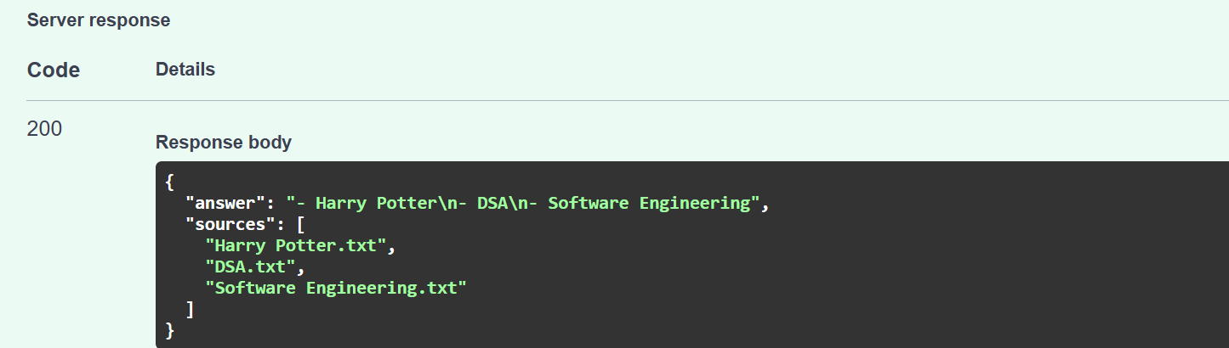
Test 4 (Grounding test):
